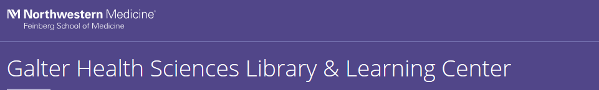
Please indicate your role: _____________________________________
(i.e. Program Assistant, Research Assistant, Program Manager, Communications Coordinator, etc.)

Please indicate your affiliation: _____________________________________
(i.e. Northwestern University, Lurie Children’s Hospital, Shirley Ryan AbilityLab, etc.)

Please indicate your department: _____________________________________
(if applicable)
 |  | Strongly Disagree | Disagree | Neutral | Agree | Strongly Agree
10:00 am  Dissemination and Outreach Overview | The material was presented in an interesting and engaging manner.
10:00 am  Dissemination and Outreach Overview | The presenter was knowledgeable about the subject matter.
10:00 am  Dissemination and Outreach Overview | The time allotted for this topic was sufficient.
10:00 am  Dissemination and Outreach Overview | The content of the session was useful and relevant my work.
10:00 am  Dissemination and Outreach Overview | Comments:
10:30 am  Panel: Dissemination in Action | The material was presented in an interesting and engaging manner.
10:30 am  Panel: Dissemination in Action | The presenter was knowledgeable about the subject matter.
10:30 am  Panel: Dissemination in Action | The time allotted for this topic was sufficient.
10:30 am  Panel: Dissemination in Action | The content of the session was useful and relevant to my work.
10:30 am  Panel: Dissemination in Action | Comments:
11:30 am  Appealing to the Masses: Tips for Publicizing your Program, Center, or Institute | The material was presented in an interesting and engaging manner.
 | The presenter was knowledgeable about the subject matter.
 | The time allotted for this topic was sufficient.
 | The content of the session was useful and relevant to my work.
 | Comments:
12:30 pm Tracking the Outputs for Your Program, Center, or Institute | The material was presented in an interesting and engaging manner.
 | The presenter was knowledgeable about the subject matter.
 | The time allotted for this topic was sufficient.
 | The content of the session was useful and relevant to my work.
 | Comments:

 |  | Strongly Disagree | Disagree | Neutral | Agree | Strongly Agree
1:00 pm  Tracking Citation Impact for Your Program, Center, or Institute | The material was presented in an interesting and engaging manner.
 | The presenter was knowledgeable about the subject matter.
 | The time allotted for this topic was sufficient.
 | The content of the session was useful and relevant to my work.
 | Comments:
1:30 pm Complying with the NIH Public Access Policy | The material was presented in an interesting and engaging manner.
1:30 pm Complying with the NIH Public Access Policy | The presenter was knowledgeable about the subject matter.
1:30 pm Complying with the NIH Public Access Policy | The time allotted for this topic was sufficient.
1:30 pm Complying with the NIH Public Access Policy | The content of the session was useful and relevant to my work.
1:30 pm Complying with the NIH Public Access Policy | Comments:
2:00 pm  Data Sharing: Guidelines and Resources | The material was presented in an interesting and engaging manner.
2:00 pm  Data Sharing: Guidelines and Resources | The presenter was knowledgeable about the subject matter.
2:00 pm  Data Sharing: Guidelines and Resources | The time allotted for this topic was sufficient.
2:00 pm  Data Sharing: Guidelines and Resources | The content of the session was useful and relevant to my work.
2:00 pm  Data Sharing: Guidelines and Resources | Comments:
2:15 pm DigitalHub: Making Research Open and Available | The material was presented in an interesting and engaging manner.
2:15 pm DigitalHub: Making Research Open and Available | The presenter was knowledgeable about the subject matter.
2:15 pm DigitalHub: Making Research Open and Available | The time allotted for this topic was sufficient.
2:15 pm DigitalHub: Making Research Open and Available | The content of the session was useful and relevant to my work.
2:15 pm DigitalHub: Making Research Open and Available | Comments:

 | No impact | Some impact | Substantial impact
Overall, please rate the degree to which your participation in this workshop will positively impact your work practices.
Overall, please rate the degree to which your participation in this workshop will impact your ability to guide/mentor others on these topics.

What was most effective about the workshop?

What was least effective?

Overall Comments: Thank you!

