NUCATS Recruitment and Retention Meta Advertisements Guide for Researchers

Accessible and action-oriented guide to the implementation of social media advertisements distributed on Meta platforms.
Last Updated: 03/02/2026
Bryant Norton, James Foran, Kathryn Macpagal, Andrés Alvarado Avila
Northwestern University
nucatsrandr@northwestern.edu

Table of Contents
Contents
Table of Contents 2
Ad Creation 3
Development of Ad Creatives 3
Development of Ad Captions 3
Getting Started 4
Creating a Meta Business Suite Account 4
Navigating Meta Account(s) 5
Establishing a Social Media Presence 7
Walkthrough 9
Gathering Resources 9
Ads Manager Walkthrough 9
Beginning a Campaign 11
Launching Ads 13
Audiences 19
Tracking Ad Performance 20
Tips & Best Practices 23
Citations 24

Ad Creation

Development of Ad Creatives
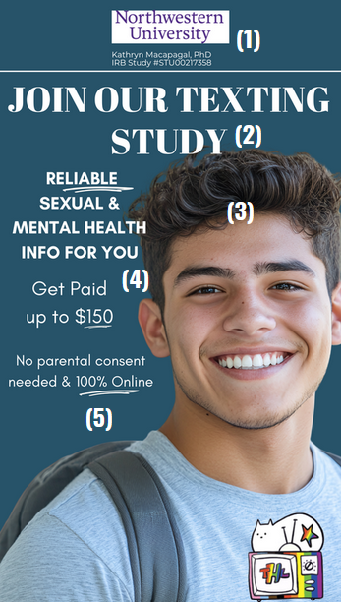
Ad creatives refer to the visual (e.g., images, videos) of an ad. Meta ads manager will allow you to select the placement of Meta owned social media platform you want to place your ads and what location in the selected platform. For example, if you want to place your advertisements on Instagram you can decide if they are shown in the posts section, stories, reels (short videos), etc. You will need to format your ad accordingly and most placements will require either a 9:16 or 1:1 size ratio.
We offer the following recommendations of key details to include in your advertisements based on past successful campaigns.
- We recommend including a clear representation of the institution to increase credibility. Listing the IRB-required information near the institution as helps create a clean aesthetic.
- The largest text on this ad describes what it is an ad for (a study) and what the broad ask for participants is (texting). Use a call to action that avoids medical/research jargon.
- We choose graphics that are representative of our target demographics. At the bottom of the ad we also have our logo.
- Incentives are not always financial. We include information on what financial incentives look like and tend to share information on what else a participant may gain from participating—usually a skill or other extrinsic motivator.
  - Note that the dollar amount is not particularly large. This is usually IRB-mandated and can marginally reduce fraud (e.g., participants faking eligibility to gain study incentives).
- Any additional information, such as the location of the study or anything that may make the study easier to participate, should also be included.

Development of Ad Captions
Alongside your ad creative will be a text caption. Meta offers options for using generative AI to create captions, but use of this feature for research studies is not recommended because runs the risk of Meta using language not approved by the IRB such as describing a paid study as a paid job opportunity or using statements like “earn quick cash”. It is instead recommend developing 2-5 captions so that you can ensure the captions accurately reflect the information being presented and ensure it follows IRB guidance. All captions are available for review following generation in Meta Ads Manager.
Because of the high variability of details across projects, we’ll offer a few general suggestions for constructing maximally impactful captions.
- Include a clear indication of payment.
  - This may not mean to include a dollar amount! Listing specific dollar amounts can attract fraud (Moore et al., 2025), which is why you should have strategies in place to detect fraudulent participation. However, mentioning pay explicitly is a significant cited incentive to participation.
- Mention key populations, research questions, or health conditions without disclosing the complete inclusion/exclusion criteria
  - Including specifics can increase the odds of fraudulent participants since they will be able to fake eligibility more easily, but mentioning broad inclusion criteria can encourage participants from key demographics to click on something they may have otherwise skipped.
  - See an example of a caption one of our LGBTQ+ teen-focused projects below.
  - 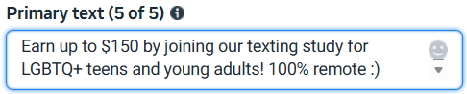
- Include the medium and/or the ask.
  - If a study is remote, for example, including this may be a reason to participate for some. Including information about the commitment required of a participant may also encourage them to click something they would have otherwise ignored.
- Include a motivation.
  - Something simple like “your opinions matter!” or “make a difference!” act as a call to action. Note that there is a separate choice, listed below, for an action included on an ad button. These may overlap with no issues.

Getting Started

Creating a Meta Business Suite Account
A Meta Business Suite Account is independent of any accounts that your team may already have set up such as a Facebook Account, page, or Instagram account. To set up a Meta Business Suite Account, your team must establish a Facebook Page. That can be done here (Facebook, n.d.).
To establish this Facebook Page, however, there must first be a Facebook Account to associate with it. We recommend following the instructions on this article to create a Facebook Account for your lab if you don’t already have one. Using a lab account as opposed to a personal Facebook account allows you to share passwords and avoids risk of a personal account being blocked due to issues with the people reporting advertisements.
- Creating a new account typically requires ID verification of some kind and may require a photo submission by staff members. Again, make sure whomever is involved in this process is comfortable doing so.
- Prior to running ads make sure that the account has a photo (e.g., your lab logo), a post (e.g., your labs mission), and a friend/follower (e.g., request yourself or someone from the team). There is no need to make the page elaborate, but light branding or a redirect to your main study page is helpful in building credibility and from experience, avoiding Meta flagging the account as spam and preventing you from running ads.
- You will need a Facebook profile and associated page to run advertisements and if you are looking to run ads on Instagram you will also need to have an Instagram account that will be associated with your ads run from the Meta platform. We recommend the same steps of populating the account with some information prior to launching ads.
Once the Facebook page is established visit the Meta Business Suite here, and follow the on-screen steps to connect your Facebook Page and Instagram Account.
Now that you’ve established and connected the account, use the tab on the left side to access “Ads Manager.”

Navigating Meta Account(s)
Meta accounts, business suite accounts, business portfolios, and ad accounts are all distinct but linked accounts. Most of these accounts are interconnected but distinct.
- Meta account – This is the account you log into on Instagram, Facebook, or Threads. A Meta account is required to establish a Meta business suite account and all the others below. A Meta account is what acts as the public face of the account and will be what participants are redirected towards.
- Business suite account – The business suite account is the account we created in the previous step. It enables you to log into Meta Business Suite and view multiple Meta accounts at once—the accounts that fall under the business suite are viewable only with your Meta account. The accounts included in the business suite account are called “business assets.” The business suite account acts as a connector between most of the other accounts.
  - 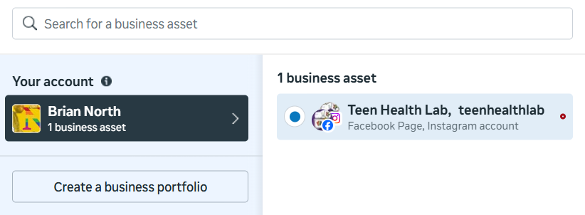
- Business portfolio – A business portfolio collects assets and the Meta accounts that manage them into one place. They are customizable and are built to focus on a specific company/business/organization and request a business email. These tend to be most useful in the hands of a project manager or other leadership staff, since they can be used to delegate and control access to ad accounts.
  - 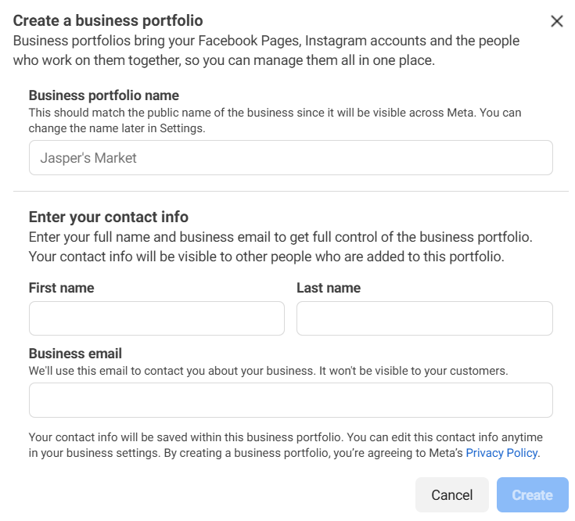
- Ad account – Every Meta account has an associated ad account by default. This is usually represented by a string of characters. Ad accounts can be associated with different staff members or created to represent different projects. When associated with a business portfolio, users can switch between ad accounts and share payment methods or management of campaigns. Of note, payment methods are ad account specific. They can be edited in Meta Ads Manager by clicking on the “payments” tab in the left column.
For more information on navigating the accounts, check out this website here (How to Create an Ad Account in Meta Ads Manager, n.d.).

Establishing a Social Media Presence
Though not strictly necessary beyond what is listed above, building even a small social media presence can make a significant difference in credibility and redirects towards your team’s project page (surveys, landing pages, screeners, etc.). There are three proposed levels of social media presence that increase based on staff availability and desire to create a meaningful presence.
- Minimal
  - Not every project will benefit from a substantial social media presence. We nevertheless recommend a barebones presence to build credibility, especially when using Meta Ads. Without any sort of branding of information on a landing page, participants are less likely to trust the legitimacy of your project and more likely to move on—especially more tech-savvy participants.
  - 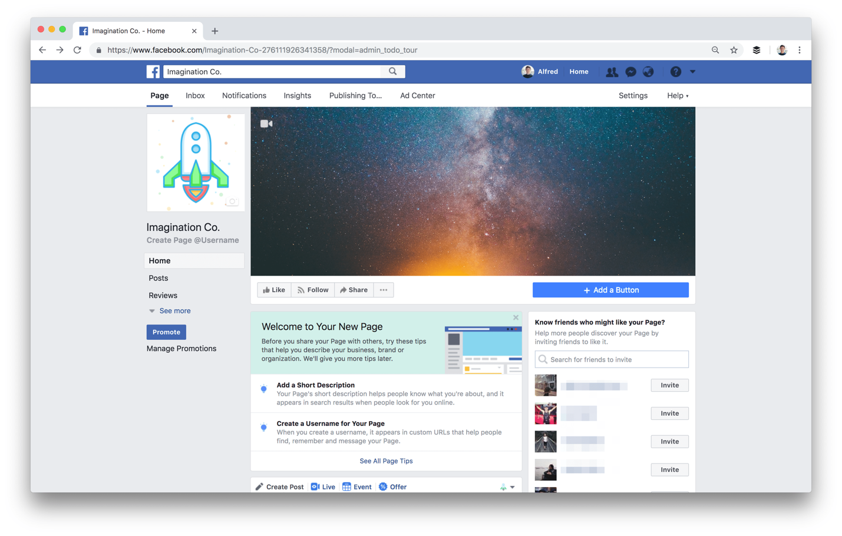
    - This image is sourced from a tutorial on creating a perfect Facebook page for your business here (Tucker, n.d.).
  - As this stock example depicts, a few simple images can take a page a long way. Any branding associated with your project, even if the branding is institute-associated rather than project-specific, can make a significant difference.
  - A brief blurb about your study will also provide much-needed context. See an example below and be sure to include a link to your study.
    - “Hello! Welcome to the Generic Study at Northwestern University! If you would like to learn more about this project, please click here to explore our landing page.”
    - Indicating where the link will send participants reduces attrition.
- Moderate
  - A moderate presence will be similar to a minimal presence with the addition of limited posting to increase credibility. This stage is optional and should prioritize low lift posting such as photos of the project team or depreciated ads.
  - 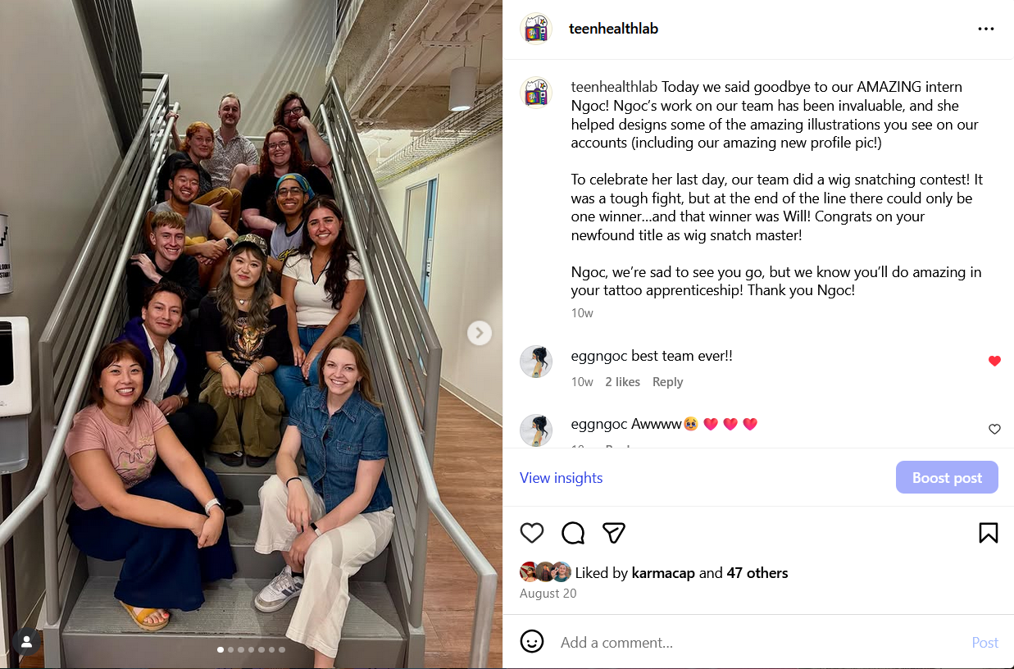
    - An example of a low lift post from the TeenHealthLab Instagram page—a photo of our team. (LGBTQ+ Teen Health on Instagram, 2025).
  - The inclusion of these posts creates a space for participants to learn more about the study without needing to search, therefore putting power & agency back in their hands.
- Influencer – The level of posting needed to create a truly generative and robust social media presence that will not only support credibility but create an online presence that can generate additional organic recruitment and function as a tool for longitudinal retention. This requires dedicated staff time equivalent to about an full time role.
  - Standard guidelines include posting 1-3 times a day at algorithmically optimized times (which change based on trends), curating reusable content, and posting or reposting content of other users on stories or feeds as much as possible.
  - If your team is interested in pursuing this path, we recommend reviewing the information here. This site provides more robust information than falls within the scope of this guide (How to Become an Influencer & Monetize in 8 Easy Steps (2025), n.d.).

Walkthrough

Gathering Resources
Prior to launching the ads you’ve created, a few more pieces of information must be gathered. For this guide, we will work with the following:
- Completed ad creative(s)
  - 1:1 and 16:9 image ratios
- Completed ad caption(s)
- An understanding of when these ad(s) should run
  - Specific start and end dates & times
Or
  - A rough estimate of recruitment milestones/timeline
- Knowledge of the available budget
- Understanding of the target population and/or a formed audience in Meta (see the “Audiences” section for more details).

Once this information is gathered, you’re ready to begin launching your ads.

Ads Manager Walkthrough
The platform, Meta Ads Manager, can be accessed via the Meta Business Suite dashboard as pictured in “Getting Started,” but may also be found by searching “Meta Ads Manager.”
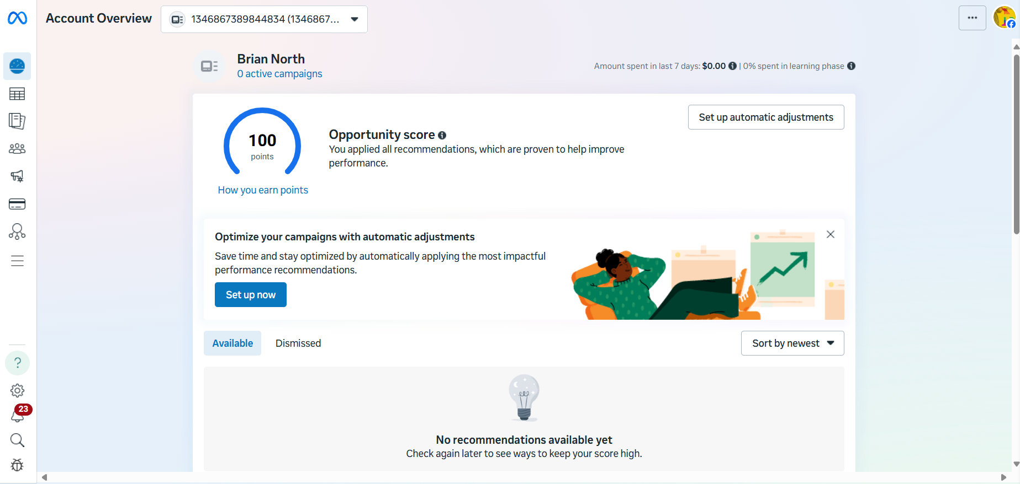
An image of the Meta Ads Manager dashboard.
The main page of Meta Ads Manager is the Dashboard, which includes information on the current status of any ongoing campaigns, suggestions from Meta on improving ad performance, and a brief look at spending in the past seven days. This page does not get much use when creating or reviewing ads, but it will serve as a hub for the purposes of this guide.

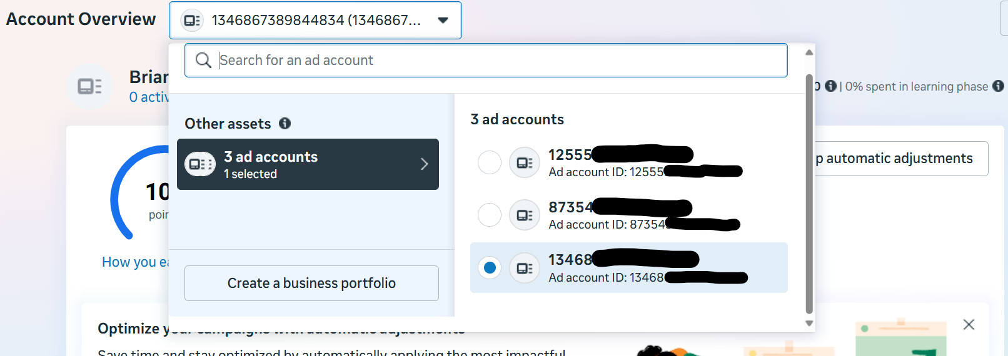
An image of the Meta Ads Manager account drop down menu for accessing alternate connected accounts.
The above shows off the account navigation tool included at the top of all pages within Meta Ads Manager. This drop down enables users to switch between connected accounts if, for example, running ads managed by different staff members in one overarching lab team.
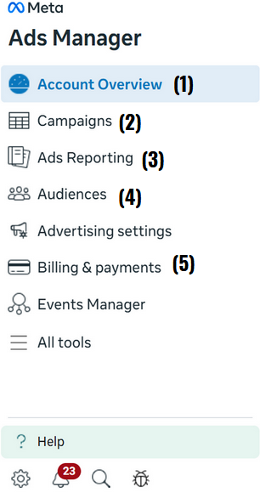
The image on the right depicts some of the main navigation items you will use to manage your ads. The “All tools” tab contains further options and information on each.
- Account Overview – This tab leads to the dashboard mentioned above.
- Campaigns – This tab contains details on any ad campaigns, past or ongoing, and is where you can create a campaign. See below for more details.
- Ads Reporting – This tab offers a suite of tools to compare various ads, ad sets, and ad campaigns to identify and maximize output. More information on this will be included in the “Tracking Ad Performance” section below.
- Audiences – This tab contains information on saved and created audiences, which can be helpful when targeting a new ad to the same population.
- Billing & payments – allows you to control your payment method(s) and view past invoices.

Beginning a Campaign
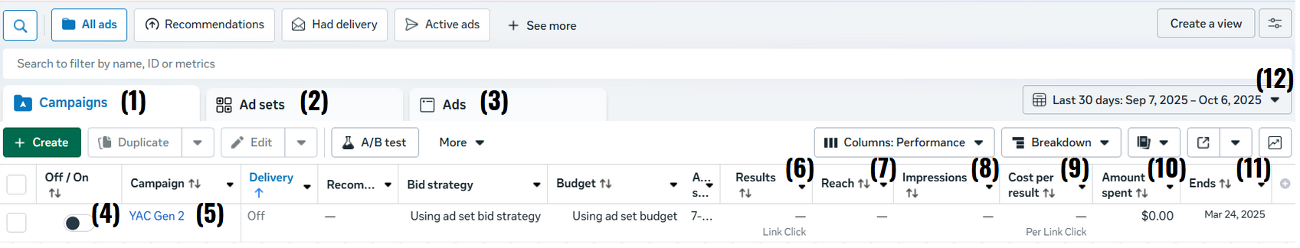
Launching a campaign requires several steps, including distinguishing between a Campaign, Ad Set, and an Ad. To begin, open the “Campaigns” tab from the lefthand menu. The below page will greet you. Note that while this is the default order of how this page is structured, you can modify it or Meta may switch the order.
An image of the Meta Ads Manager “campaigns” page with tools numbered 1-12.
- This tab consists of the campaigns that act as the umbrella that houses groups of ads, or ad sets, which are broken down into ads (campaign – ad sets – ads). Campaigns all have the same objective (engagement, traffic, awarenss) and ad sets allow you to create multiple ads that have the same objective as the campaign.
- Ad sets can be used to organize several ads at once including modifying daily budget.
- The ads tab includes the individual specific ads that have been designed and/or launched. This tab will be used to make edits prior to launching a campaign and to follow live implementation status.
- The On/Off switch will activate or deactivate a campaign. This does not launch an ad, but controls whether it can follow its planned schedule (i.e., you have an ad planned to run from 10/10 – 11/11, but even if the ad campaign is set to “On,” it will not run on 11/12 because it is not scheduled to run.)
  - Ad campaigns, ad sets, and ads all have individual on/off switches. If any layer is set to “off,” the ad will not run.
  - This option may be used to quickly halt an ad.
- The campaign/ad set/ad name. The user creates these—be sure to use something distinguishable from any other instances. It is helpful to give these names that help you distinguish between them which is useful when pulling reports (e.g., Study XYZ – 20-25 y.o – 02.09.2026).
- Results reflect the number of actions taken by the audience. This is variable depending on what is selected. For most studies it will make sense to select landing page views as the performance goal since Meta will use the algorithm to target individuals who are likely to click on the advertisement link and let the page successfully load.
- Reach and Impressions are similar but distinct—reach is the amount of unique accounts that saw the ad.
- Impressions are the number of times an ad was shown, regardless of how many unique accounts did so. For example, if an account sees the same ad 8 times, this would count for 8 impressions, but only 1 reach.
- Cost per result is an automatic calculation that divides the amount of money input into a campaign (considering timing & how much of it has been used already) by the amount of results captured. As a reminder, results are variable depending on the type of campaign. In most cases, cost per result will reflect the cost per page view or link click.
- The amount spent column represents the total amount of money spent thus far on the campaign and will be a crucial measure to asses campaign performance and budget.
- The “ends” column refers to the end date set by the user for the campaign. For example, if the campaign is set to run from 10/10 – 11/11, the “ends” column will read “11/11.”
  - This date may also be in the past, as it updates to reflect the accurate final date of campaign execution, regardless of the initial set time.
- This dropdown menu allows users to specify the date range of the information they’re looking for. If a campaign is not appearing but seems as though it should, this is likely the culprit setting. Adjust it to include the dates of campaign deployment.

Launching Ads
This section will take you through a step-by-step process of launching an advertisement using the Meta ads platform.
- Select the “Campaigns” tab, then press the green “Create” button. This will launch a pop-up menu.
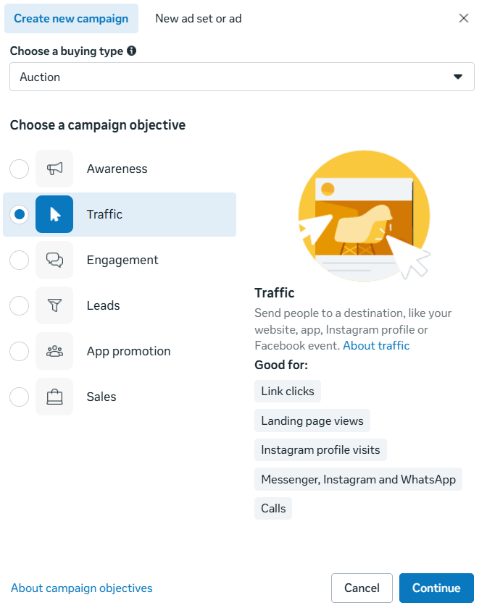
- The pictured menu allows users to select what campaign objective best fits them. For most recruitment efforts, “Traffic” is the best option as it encourages link clicks or landing page views. Other options are more optimal for sales of a product and therefore are not the best option for recruitment. Click “Continue.”
- In most cases, it is better to select “Manual traffic campaign”, otherwise Meta will utilize it’s AI features which can be useful for sales but not for reaching research participants. For the purposes of this guide, the manual option will be demonstrated.
- 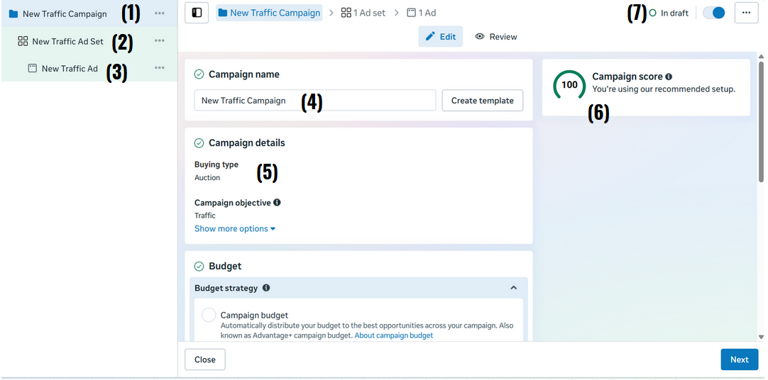 Creating a new campaign will open an empty slate to input information on.
- The overall campaign name. The “…” menu will open options to add sub ad sets, duplicate the entire campaign, copy, delete, etc. Double clicking on the name will allow users to change it.
- The above details are true for ad sets as well.
- The above details are true for individual ads as well.
- This will also enable editing of the campaign name.
- “Campaign details” reflects the campaign objective selection from the previous steps and also includes the buy-in type. Auction is ideal for research study recruitment as it focuses on performance, conversions, or traffic, while reservation focuses on brand awareness.
- The campaign score is often misleading as it tracks how close your campaign is to Meta’s suggestions which are not always applicable to the kind of advertising conducive to recruitment.
- The “In Draft” switch acts similarly to the on/off switch from the campaign overview.
- After updating any details on the ad campaign page, click “next” in the bottom right corner.
- The next page is the ad set page. This menu has a host of options to edit for the purposes of a successful campaign that’s in line with budgets and recruitment goals. The conversion option should be set to “website” as this will enable users to input the link to a screener, survey, etc. While you can send them to be able to contact you, consider that this adds an extra step for participants to express interest.
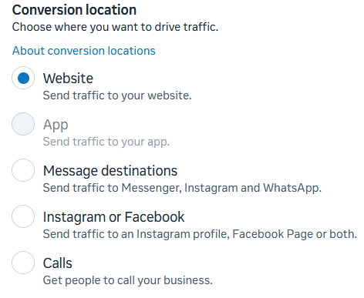
- Performance goals may differ depending on study needs. “Maximize number of landing page views” tends to be the best option for screener/intake access from participants, but link clicks may achieve the same goal. The difference is that landing page views targets people who are likely to visit your landing page and let it load compared to link clicks which just optimize people who will click (but may not wait for the page to load).
- Cost per result goal and value rules is helpful when you want to keep the average cost per result a certain amount during your campaign. To make the most of this feature you will need to utilize past performance data which may not be available to studies new to using meta to recruit research participants. Most teams can leave these fields blank.
- 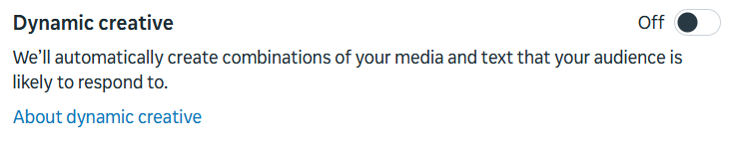 If your study has multiple ad creatives and/or captions, the “Dynamic creative” option is a useful tool to generate maximally effective combinations.
- 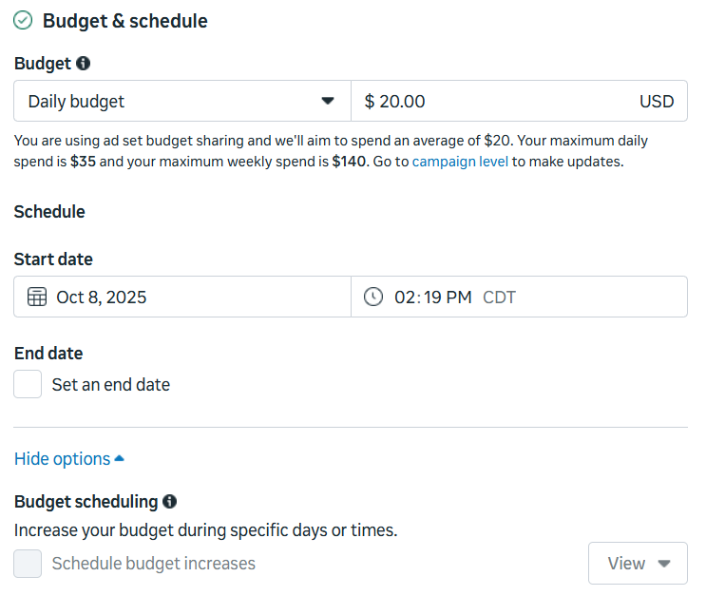 The budget & schedule options are critical to managing your daily or lifetime budget. Daily budget is more specific to daily spend, while lifetime budget might be divvied up differently, but each represent the total amount of money spent on this ad set at a given time.
- The start date represents when the ads will launch. Meta will not allow you to proceed if the date OR time is in the past. An end date is optional but recommended to control budget.
- The budget may also be increased during specific days or times. An example of when this may make sense is if the target population is LGBTQ+ individuals and the recruitment window crosses over with Pride month.
- Audiences are a bit more complex than many of the other features of creating an ad set. See the “Audiences” section below for more details. At this stage, select the options that best reach your population of interest. There are more advanced options like creating a lookalike audience which use data like targeting individuals who have viewed a percentage (e..g, 50% or more) of your video advertisement to target other individuals who are likely to engage with your advertisement. Some of the basic targeting demographics include:
  - Age, location, gender, language. Restrictions apply to those under the age of 18.
  - We recommend scrolling down to the Advantage+ audience section and selecting “Switch to original audience options,” as this will reduce the AI influence over audience placements which may preclude certain audience options, such as selecting audiences age 13-18.
  - 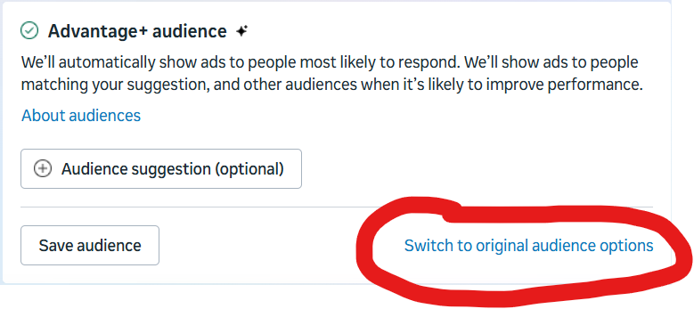
- Placements refer to the locations that your ads will be displayed across Meta platforms. The best selections here will be variable depending on a study’s needs. We also recommend disabling the Advantage+ option, as it will enable users to choose the specific placements and exclude those that may not make sense.
  - In general, these placements reach these populations:
    - Instagram captures a younger audience.
    - Facebook captures an older audience.
    - Threads, as of time of writing, has limited reach.
    - Reels and stories, regardless of platform, tend to have a wide reach. This does not necessarily extend to successful performance as you may not be reaching your target population.
    - In our experience, Facebook-based ads have higher levels of fraud, but with the appropriate fraud prevention measures may be appropriate if you are trying to reach older (e.g., 35+) adults.
- After choosing the best placements for your ads, click “next” at the bottom right to move onto the final main step.
- This page is to edit and add to a specific ad within the set & campaign developed in the previous steps.
  - Ad name can be edited to further distinguish between your ad creatives if you have multiple of them. For example, naming one ad “RCT ad with images of real people” or “RCT ad with carton images”. When you are looking at metrics these names can help you quickly identify metrics at the individual ad level.
  - Partnership ad allows you to disclose if you are running this ad as part of a partnership. While common for brands looking to sell products, it Is far less common for research study recruitment.
  - Identity is the Facebook page and/or Instagram that will show as running the account which users can click on and visit.
- Ad setup is where you will be able to select the creatives use in your advertisement. The creative source will be set by default to manual, which ill be the main option that we use. Advantage+ ads will add in materials from a catalog that is primarily only applicable to brands selling products.
  - Format is viable as whatever makes the most sense with the creatives you have generated, especially if you decided to make more than our initial baseline suggestions.
  - Destination, for recruitment, will always be a website URL. The URL should be the link to your survey or screener.
- Ad creative allows you to take the image(s) made earlier in the guide and place them into the various sizes of posts that are applicable across platforms. Using the right hand “ad preview” menu after uploading the media will show exactly how these images will look to users.
  - The primary step in the media upload menu is the “media” option, which is the place to add the ad creatives made to show off to those prospective participants.
  - The two primary sizes (as outlined above) are 1080 x 1080 and 1080 x 1920, for square posts and reel posts, respectively. The applicable size can be chosen in the crop tab, and different versions can be uploaded to the varying slots by pressing “replace.”
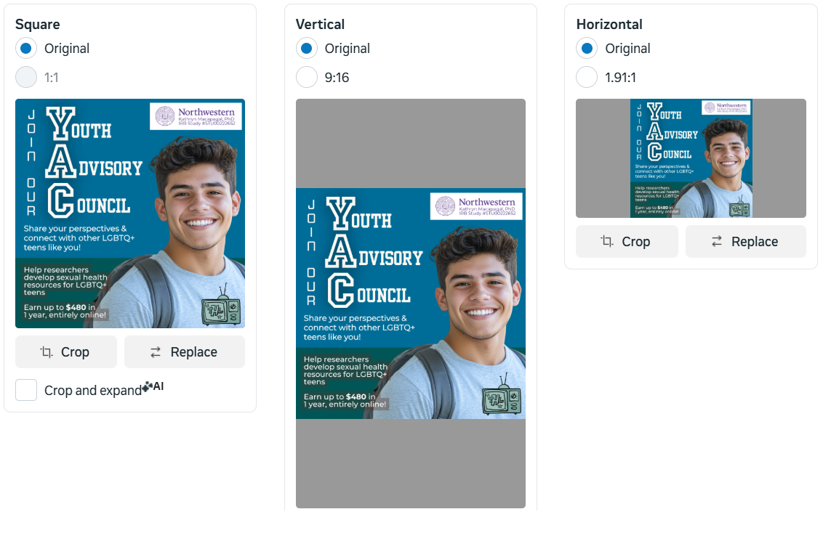
  - The “Text” tab can be ignored for the time being, as these are easier to edit outside of this menu.
- 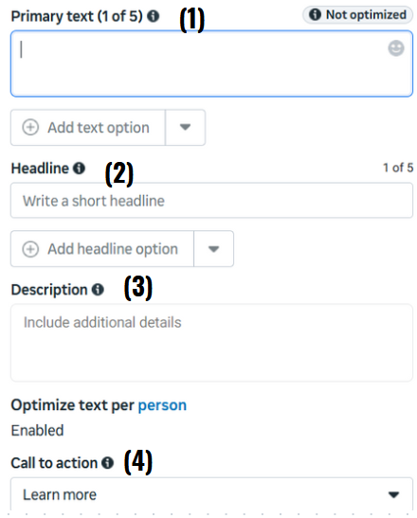
  - Captions are added here. The platform supports up to 5 by using the “add text option” button.
  - Headlines will appear in certain ads to add more information, but not others, depending on where the ad is distributed.
  - The description tends to be included in fewer placements but is reflective of the ad campaign’s “ask.” In the case of recruitment, this is likely a brief brief description of the study and ask.
  - The call to action has limited options. Our projects tend to find “learn more” makes the most sense, but your team’s mileage may vary.
- There are additional options available, such as A/B testing that allows you to compare performance between ads, but this sums up the primary aspects of creating an ad. You’re ready to publish this ad!

Audiences
- While in Meta Ads Manager, click on the “Audiences” tab on the left-hand side. This will open a list of your account’s audiences. It’s likely that at the moment, you have none!
- The dropdown menu to create a new audience will look like this: 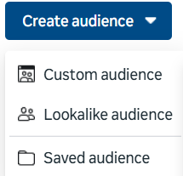
  - Custom audience refers to creating an audience based on pre-existing traffic to pre-established sources, usually related to your Meta activity including leads from previous ad campaigns (leads), Instagram or Facebook account interactions, and other information. Do not upload any participant data as this is a breach of confidentiality. Be careful when uploading website data as this may also be considered uploading sensitive data depending on the content of the website data.
    - Each type of custom audience will have a different set of fields to fill out. Most of these fields will be restricted based on the pre-existing data selected. Other options are described by Meta itself.
  - Lookalike audiences take in information from pre-existing sources and create an audience that matches that audience to a certain degree. The percentage correlates with how specific this audience will be with lower numbers reflecting more similar audiences.
  - Saved audiences tend to be most immediately useful, if not always most effective in the long-term. These allow users to create audiences that can be used and re-used while developing an ad campaign, as mentioned above.
- Hovering over or clicking on individual audiences provides information on where the audience has been used in the past, what campaigns it has been used in, and performance statistics both estimated and otherwise.

Tracking Ad Performance
There are two main methods of tracking ad performance in Meta Ads Manager. These methods each capture different pieces of information and are equally important depending on the immediate tracking needs of the project.
Cost, reach, and at-a-glance stats:
- For the first method, navigate towards the “Campaigns” tab as used to set up the campaigns in the first place. From there, make sure the calendar setting in the upper right corner reflects the timeline you are looking to analyze.
  - From here, you may choose “Campaigns,” “Ad sets,” or “Ads” as your area of focus. All three categories have editable displays by selecting the “columns” dropdown and can be made at least semi-identical. For the purposes of this guide, we will be using examples from the “Campaigns” tab.
- Our team uses the “performance” preset of columns for most of our immediate and/or everyday uses. 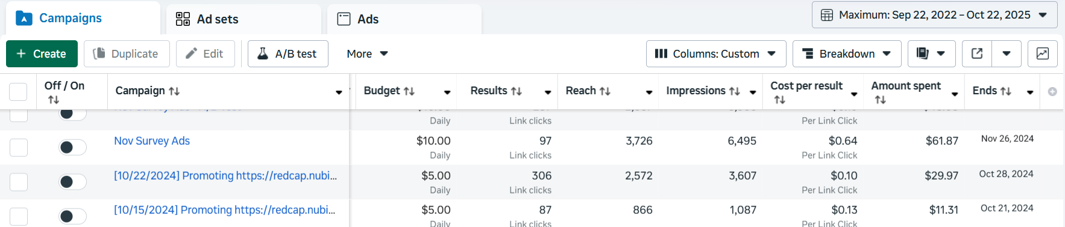
- Many of the columns are fairly self-explanatory. “Budget” reflects the daily budget applied by the user, “Results” describes the amount of link clicks and/or any other chosen metric, and “Reach” and “Impressions” describe the number of unique accounts that saw your ads and the amount of times your ads were displayed, respectively.
- “Cost per result” is a key piece of information that can inform fairly significant decisions. This rate indicates how successful a campaign was and is often used to inform strategies moving forward. Many common websites will advise that keeping the cost per result at or around $1 is a good rule of thumb (Cost Per Click (CPC) Rates (2025) - Business of Apps, n.d.). However, in research, especially for niche populations, the cost per result can be extremely variable. The best rule of thumb will be—does this number seem reasonable to you?
  - If the answer is “no,” then this is a great time to review the campaign materials and choose different options including the ad creative, selected audience, or even total budget as several methods may be accurate, but only recruit at a trickle and therefore need reduced budgets to match the recruitment rate.
  - These numbers are estimates, even though they may seem to be objective. Keep that in mind!
  - Our examples listed above are representative of some of our more successful campaigns, but the amount per result varies widely based on population of interest and eligibility criteria as previously mentioned.
- “Amount spent” is more variable than it appears at a glance—it is not always representative of the exact amount dedicated to a campaign. Instead, if there are multiple ads running or the ad runs for more than a few days, it may be an adjusted amount based on the Meta algorithms (i.e. some ads may be pushed further than others if they are performing better).
  - This should never go over the budget you selected on initial setup.
Extended ads reporting
- Beneath the “Campaigns” tab is the “Ads Reporting” tab. This toolset allows users to curate their own specific reports that can be exported and customized to reflect specific needs. The majority of interaction will be done on the reports section, with exports acting as a history of exported data.
- When creating a report, you will be met with the following options. Choose which works best for your needs—we will be using the “Trend Line Chart” for this example, as it is the layout we use most.
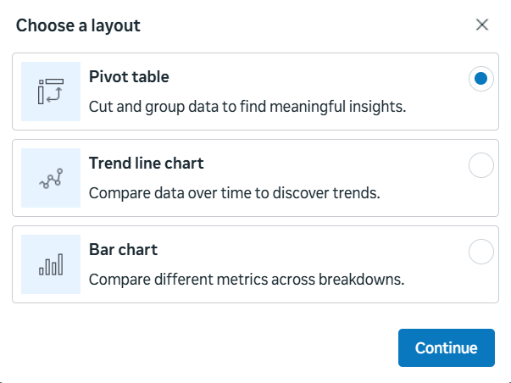
- 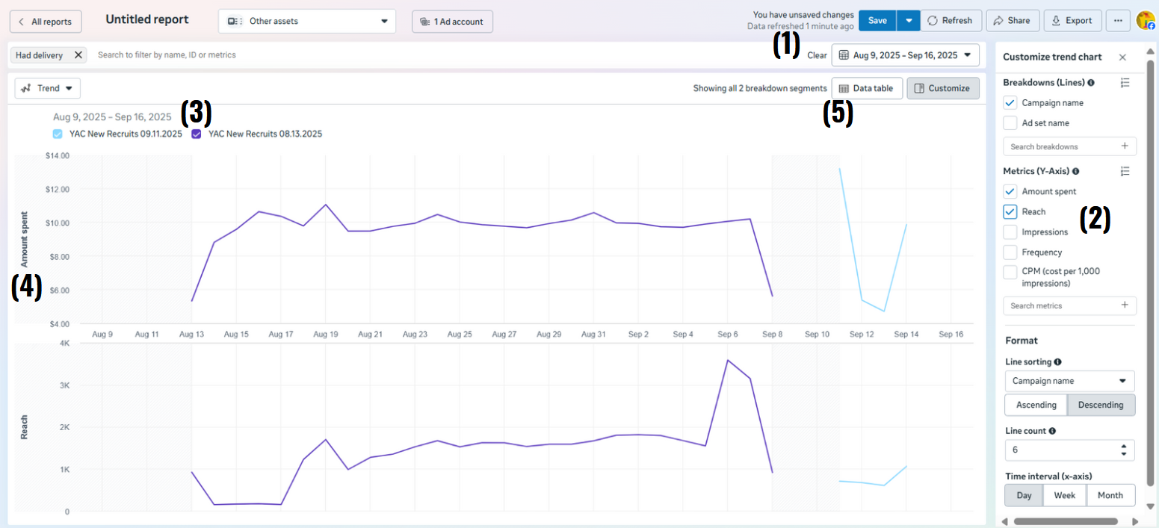
- This number surrounds several regular familiar & important tools, such as the “save” button, the date range, and the distribution options (share, export).
- This window pops up when selecting “customize” right beneath the date range. The selectable metrics are the main tools of this window. They allow users to choose which statistics they observe. Up to two can be selected at once for comparison.
- These labels describe the data sources pulled for the information provided. For example, our team ran two different ads during this block of time, and they are defined here.
- The y-axis is determined by the menu in step 2, but it is important to review this and examine the scale between variables, as they may be significantly different. In our example, the amount spent does not break $14, while the reach is well into the thousands.
- This button edits the view of the information. It may be presented as a table as well as a chart.
- There are more advanced comparison techniques. We encourage anyone interested in creating more robust ad reports to seek out further information here (“Facebook Ads Reporting,” n.d.).

Tips & Best Practices
- Meta and its services are always changing. The likelihood of aspects of this guide becoming outdated is unfortunately high. There are also instances of features disappearing or reappearing. Take care to review any potential changes in the case that this information is outdated.
- Do not edit an ad campaign after launching. Meta ads enter a learning phase after launching. If edits are made the learning phase will restart. During the learning phase your cost per result may be higher.
- Check the ad status regularly in the first few days of deployment. This can inform if you need to make edits to optimize results. Again, try to make edits after the ad has concluded the learning phase.
- Adding the dollar amount for participation in the ad can increase odds of fraudulent participation, (Moore et al., 2025). If you add the dollar amount ensure to have fraudulent mitiation strategies in place.
- The AI-powered Meta Audience Advantage+ has limited benefits for research studies since we are often trying to reach specific populations as opposed to reaching as many people as possible. This may be a good option if you have a less restrictive inclusion criteria but may lead to overspending if you have a more stringent inclusion criteria.
- The AI-powered Meta Advantage+ service will often reactivate upon changes to an ad set or campaign, including duplication. Be sure to change the settings back so they match the project requirements.

Citations
CLRN team. (2025, January 21). How to Create a Facebook Page Without a Personal Account. California Learning Resource Network. https://www.clrn.org/how-to-create-a-facebook-page-without-a-personal-account/
Cost Per Click (CPC) Rates (2025)—Business of Apps. (n.d.). Retrieved November 18, 2025, from https://www.businessofapps.com/ads/cpc/research/cpc-rates/
Facebook. (n.d.). Retrieved November 18, 2025, from https://www.facebook.com/pages/creation/?ref_type=facebook_business_website&campaign_id=163681540489385
Facebook Ads Reporting: How to Track Performance. (n.d.). AdEspresso. Retrieved November 18, 2025, from https://adespresso.com/guides/facebook-ads-beginner/analyze-your-campaigns-performance/
How to Become an Influencer & Monetize in 8 Easy Steps (2025). (n.d.). Retrieved November 18, 2025, from https://later.com/blog/become-an-instagram-influencer/
How to Create an Ad Account in Meta Ads Manager. (n.d.). Meta Business Help Center. Retrieved November 18, 2025, from https://www.facebook.com/business/help/407323696966570
LGBTQ+ Teen Health on Instagram: “Today we said goodbye to our AMAZING intern Ngoc!” (2025, August 20). Instagram. https://www.instagram.com/teenhealthlab/p/DNl8P8FulTn/
Meta for Business (formerly Facebook for Business). (n.d.). Retrieved November 18, 2025, from https://business.facebook.com/business/loginpage/?next=https%3A%2F%2Fbusiness.facebook.com%2Flatest%3Fnav_ref%3Dmfb_get_started_section_second_direct_link&login_options%5B0%5D=FB&login_options%5B1%5D=IG&login_options%5B2%5D=SSO&config_ref=biz_login_tool_flavor_mbs
Moore, J. B., Chieng, A., Pirner, M. C., Pajarito, S., Vogel, E. A., Bowdring, M. A., Bullard, L., Robinson, A., & Prochaska, J. J. (2025). Mitigating fraud in a fully decentralized clinical trial of a digital health intervention. Annals of Behavioral Medicine, 59(1), kaaf047. https://doi.org/10.1093/abm/kaaf047
Tucker, D. (n.d.). How to Create the Perfect Facebook Page for Your Business: The Complete A to Z Guide. Gather Social. Retrieved November 18, 2025, from https://www.gathersocial.co.uk/blog/how-to-create-the-perfect-facebook-page-for-your-business-the-complete-a-to-z-guide

