Title of Protocol: Scoping Review: The Science of Physician Caring
Date: Initially drafted January 31, 2020. Minor changes were made prior to posting date.
Version: 1.0
Authors:
David Burstein, M.D. (1), Faith Svigos (2), Akash Patel (2), Neha Reddy (2), Kelly Michelson, M.D., M.P.H. (3), Linda O’Dwyer, M.A., M.S.L.I.S. (4), Mark Linzer, M.D. (5), Jeffrey Linder, M.D., M.P.H. (1), David Victorson, Ph.D. (6)
Author Affiliations:
1. Division of General Internal Medicine and Geriatrics, Northwestern University Feinberg School of Medicine,
Chicago, IL, United States.
2. Feinberg School of Medicine, Northwestern University, Chicago, IL, United States.
3. Pediatrics, Northwestern University, Chicago, IL, United States.
4. Galter Health Sciences Library & Learning Center, Northwestern University, Chicago, IL, United States.
5. Medicine, Hennepin Healthcare, Minneapolis, MN, United States.
6. Medical Social Sciences, Northwestern University, Chicago, IL, United States.
Amendments: Significant changes to our research protocol will be addended to this document as needed. Final methods will be reported in our manuscript.
Support: No financial support, no review funder or sponsor.
Abstract:
Overarching Hypothesis: Clinical systems and work environments which enhance physician caring will result in better medical outcomes, better patient experience with healthcare, and less physician burnout.
Background: Caring is a fundamental act in healthcare that generally involves reciprocal relationships in which one individual helps or supports another in need¹. Though it has received little scientific attention in the medical literature, it has long existed as a concept in nursing²⁻³. In nursing, it has been defined as an action (e.g., a nurse caring for his or her patient) as well as a disposition or attribute (e.g., a caring nurse will advocate for his or her patient). In medical practice, perhaps other than Francis Peabody’s oft-quoted message that, “the secret of the care of the patient is in caring for the patient,”⁴ there is an absence of a popular, clear conceptualization of what it means when a physician “cares” for his or her patient.

Rationale: Our review will explore physician caring, which for the purpose of this endeavor we will conceptualize exclusively as a verb. The adjective form of caring (Merriam-Webster definition: “feeling or showing concern or kindness to others”) has definitional overlap with commonly used terms such as compassion or humanism, and thus it does not represent a gap in the literature. Caring (v), on the other hand, defined by Merriam-Webster as “to give care” and “to feel interest or concern,” spans aspects of the doctor-patient relationship such as altruism, empathic concern, professionalism, and using one’s knowledge or skill to address a medical problem. In this way, we view the concept of physician caring (v) as an avenue to integrate both the interpersonal and technical aspects of medical practice – for which each are essential for high quality care – into a single construct.

Purpose: The gap in the literature with respect to conceptualizing caring in medical practice has implications for patient care, patient experience, medical education and training, and physician burnout. Interventions which enhance physician caring are hypothesized to result in better medical outcomes. Many factors that are positively associated with patient experience, such as listening, attentiveness, communication⁵, and adequately addressing the problem, are also hypothesized to be positively associated with physician caring. Empathy declines during medical education & residency⁶, and teaching and training in how to meaningfully care in the midst of these changes is hypothesized to promote resilience, work satisfaction, and humanistic practice tendencies after training. Lastly, thoughtful measurement of physician caring may serve as a powerful balancing measure against the onerous job demands, external economic and regulatory factors, and frustrating information technology that are driving physician burnout⁷.

a priori Preliminary Definition of Physician Caring (v) (October, 2019): The act of having or showing concern for another’s well-being, combined with the use of one’s experience and resources to promote their health.
Working Definition of Physician Caring (v) (as of January, 31st 2020): The act of having concern for or commitment to another’s welfare, while using one’s experience, skills, and resources to promote their health.
Research Question: “What is the state of science around physician caring, and how has it been conceptualized thus far?”
Objectives:
- Identify existing research definitions, frameworks, and conceptual models of caring in medical literature.
- Quantitatively summarize the number of studies and methodological approaches that have been used in the study physician caring.
- Collate a large body of scientific and theoretical literature on caring in medical practice.
- Provide a synopsis of how caring in medical practice has been or could be conceptualized.
- Identify gaps in the health care literature on physician caring that will guide future studies and initiatives.
Methods:
Protocol: A scoping review study will be performed using a framework proposed by Arksey and O’Malley⁸ and expanded upon by Daudt et al⁹.
Sources of Evidence: We will search primary literature from all years in PubMed MEDLINE, Embase (embase.com), PsycINFO (Ebsco), CINAHL (Ebsco) and CENTRAL Register of Controlled Trials (Wiley). Review articles will be removed, and later reviewed by at least one author after completing our title and abstract screen for all articles. The reference lists of key reviews and articles will be screened for additional articles. At this time, we do not have plans to review grey literature for this topic.
Search Strategy: Our search terms were initially constructed for use in PubMed and are shown below. Minor changes will be made for use in other databases, and search strings used will be reported in our final manuscript.
Title/Abstract: theor*, philosoph*, concept*, framework, construct*, model, “doctor-patient relationship(s)”, “patient-clinician relationship(s)”, reciproc*, suffer*, “bedside manner”
Qualifying Terms (must have 1)
}
MeSH: Physician-patient relations, trust, altruism, physician’s role, character
AND
Key Terms (must have 1)
}
Title/Abstract: Caring, compassion*, humanis*, (purpose AND meaning), “to care”
MeSH: Empathy, Compassion fatigue
AND
}
Title/abstract: Physician(s), doctor, residency, medical student(s), clinician(s)
Population Terms (must have 1)
MeSH: "Physicians"[Mesh:NoExp], "Internship and Residency," "Students, Medical"

Approach to Training Reviewers & Pilot Screen: Distinguishing between aspects of the doctor-patient relationship will be performed with the use of the conceptual model shown below, which was adapted from the National Academy of Medicine’s Taking Action Clinician Burnout report⁷. The appendix at the end of this report includes definitions of many concepts that are either included in this model or are a potential cause for confusion with respect to our definition of physician caring. A pilot screen has already been performed using Rayyan of a random sample of 499 articles by 4 reviewers (each reviewer screened all 499 articles) to ensure the appropriateness of our research question, search strategy, scope of literature, preliminary inclusion and exclusion criteria, and adequacy of training procedures.
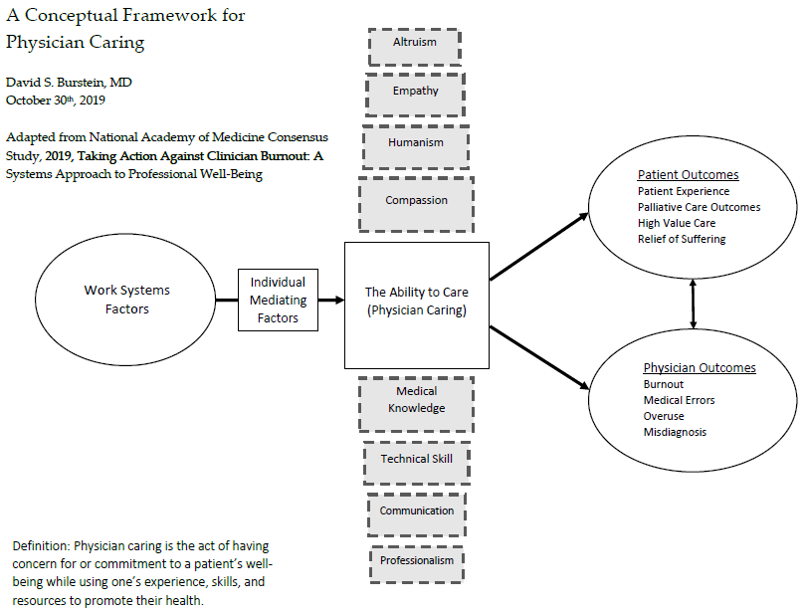

Title & Abstract Screen: After completing the pilot screen, all title and abstracts from our search queries will be reviewed by one reviewer (D.B.), and all title and abstracts will be randomly reviewed in equal thirds by 3 reviewers (F.S., A.P., N.R.), such that two individuals are reviewing each title and abstract. We will use the eligibility criteria below to assess whether each article warrants full text review. We will aim for >90% agreement on articles which meet criteria for full text review. Conflicts will be settled amongst this review team of authors (D.B., F.S., A.P., N.R.). We will use Covidence for our review.
Eligibility criteria: Our search terms were constructed to yield articles which focus on each of the following three domains: 1) caring in clinical practice, 2) conceptual models and frameworks, and 3) physicians and clinicians. We will use iterative screening criteria to identify articles for full text review. At time of this writing, our positive screening criteria of titles and abstracts are 1) Articles that focus specifically on “Physician Caring” or “Clinician Caring,” (either based on the use of the word itself, or if the title and abstract suggest that the article is closely akin to our working definition of physician caring), 2) Studies which synthesize or integrate disparate aspects of the doctor-patient relationship that explicitly mention or incorporate physician caring, and 3) articles which focus on the doctor-patient relationships that mention frameworks, models, etc., in the abstract. Our negative screening criteria are 1) Articles which focus on patients’ experience of caring; 2) Articles on clinical-practice guidelines, care of specific patient sub-populations, and models of care delivery which do not emphasize, focus on, or explore physician caring; 3) Articles which have an obvious, singular focus which fits into previously established bodies of medical literature (e.g., palliative care, shared-decision making, patient-centered care, empathy, compassion, humanism, etc.); 4) Articles which do not pertain to medical practice.
Full Text Review: Full text review will be divided amongst the review team (D.B., F.S., A.P., N.R) such that each article will be reviewed in full by two authors. Determination of final inclusion criteria for data extraction will occur via an iterative process with faculty input after general review of the total number and scope of articles which meet eligibility criteria for full text review. Our preliminary criteria for inclusion in our final analysis is articles which have research definitions, frameworks or conceptual models of caring in medical practice.
Charting Methods: We will create a chart for data extraction that may be changed iteratively. Data extraction from each article will be performed independently by two authors. Data of interest which will be extracted includes title, author, year of publication, type of publication (e.g., scientific work, philosophical or theoretical work, viewpoint or essay, or other), method used (quantitative, qualitative, education/curriculum, general discourse, or other), methodological basis of the work (conceptual model, framework, research definition, or exploratory methods), how caring was incorporated (i.e., article focused on primarily caring, or caring was a subtheme or feature of an article that focused on another concept or topic). If feasible, we may chart other features of the doctor-patient relationship which are included in the article (e.g., empathy, humanism, compassion, knowledge, technical skill, communication skills, patient-centeredness, etc.). Depending on the articles which meet criteria for data extraction, we may judge the rigor, quality, or contents of scientific works with a validated framework.
Data Synthesis and Anticipated Results (subject to minor changes)
- A list of existing research definitions, frameworks, and conceptual models of physician caring.
- A summary of the number of scientific studies on physician caring which details the methodological approaches used.
- An overview of the aspects or features of physician caring that have been studied or discussed.
Anticipated Conclusions
- There is a small, substantive body of literature on caring in medical practice.
- There are opportunities to further develop and study the concept of physician caring for the purpose of research, education, and health system improvement.

References:
- Schwenk TL. Physician well-being and the regenerative power of caring. JAMA. 2018 Apr 17;319(5):1543-1544.
- Morse JM, Solberg SM, Neander WL, Bottorff JL, Johnson JL. Concepts of caring and caring as a concept. ANS Adv Nurs Sci. 1990 Sep;13(1):1-14.
- Beck CT. Quantitative measurement of caring. J Adv Nurs. 1999 Jul;30(1):24-32.
- Peabody F. The Care of the Patient. JAMA. 1927;88(12):877-82.
- Zulman DM, Haverfiled MC, Shaw JG, et al. Practices to foster physician presence and communication with patients in the clinical encounter. JAMA. 2020 Jan 7;323(1):70-81.
- Neumann M, Edelhauser F, Tauschel D, et al. Empathy decline and its reasons: a systematic review of studies with medical students and residents. Acad Med. 2011 Aug;86(8):996-1009.
- National Academies of Sciences, Engineering, and Medicine 2019. Taking Action Against Clinician Burnout: A Systems Approach to Professional Well-Being. Washington, DC: The National Academies Press.
- Arskey H, O’Malley L. Scoping studies: towards a methodological framework. International Journal of Social Research Methodology. 2005 8(1):19-32.
- Daudt HM, van Mossel C, Scott SJ. Enhancing the scoping study methodology: a large, inter-professional teams’ experience with Arskey and O’Malley’s framework. BMC Med Res Methodol. 2014 Mar 23;13:48.

Appendix 1: Relevant definitions of similar and related constructs.
- Compassion:
  - The awareness and acknowledgement of the suffering of another and the desire to relieve it (Gold Humanism).
  - Sympathetic consciousness of others' distress together with a desire to alleviate it (Merriam-Webster)
    - Sympathy: a relationships between two persons wherein whatever affects one similar affects the other.
  - Schwartz Center defines compassionate care as having four essential elements:
    - Empathy, emotional support, and a desire to relieve a patient’s distress and suffering
    - Effective communication at all stages of a patient’s illness and treatment
    - Respective patients’ and families’ desires to participate in making health care decisions
    - Knowing and relating to the patient as a whole person, not just a disease
- Humanism: Humanism in healthcare is characterized by a respectful and compassionate relationship between physicians, as well as all other members of the healthcare team, and their patients. It reflects attitudes and behaviors that are sensitive to the values and the cultural and ethnic backgrounds of others. The humanistic healthcare professional demonstrates… integrity, excellence, collaboration & compassion, altruism, respect & resilience, empathy, service (Gold Humanism).
- Empathy:
  - A conscious, strenuous, mental effort to clarify a patient’s muddy expression of her experience using a soft interpretation of her story (Dohrenwend 2018).
  - The ability of the physician to understand the patient’s situation, perspective and feelings (and their attached meanings), communicate that understanding and check its accuracy, and act on that understanding with the patient in a helpful (therapeutic) way (Neumann 2011).
- Communication: A process by which information is exchanged between individuals through a common system of symbols, signs or behavior (Mirriam-Webster).
- Patient-Centered Care: “Care that is respectful of and responsive to individual patient preferences, needs, and values and [ensures] that patient values guide all clinical decisions" (Institute of Medicine, 2001)
- Shared-decision making: “An interpersonal, interdependent process in which the health care provider and the patient relate to and influence each other as they collaborate in making decisions about patient’s health care” (Legare 2013).

