PubMLST database workflow for Neisseria gonorrhoeae analysis
Publicly available Neisseria gonorrhoeae genomes predominantly represent in vitro-derived nonpiliated variants
Iryna Boiko, MD, PhD^{*1} , Selma Metaane, PharmD, PhD^{*1} , and Hank S. Seifert, PhD^{1#}
¹Department of Microbiology-Immunology, Feinberg School of Medicine, Northwestern University, Chicago, IL 60611, USA
*Joint authors. These authors contributed equally: Iryna Boiko and Selma Metaane.
#Corresponding author: Dr. Hank S. Seifert, Phone:+1 312 503 9788, h-seifert@northwestern.edu.

The Public Databases for Molecular Typing and Microbial Genome Diversity (PubMLST) database is a freely accessible, web-based resource (https://pubmlst.org/). It employs the Bacterial Isolate Genome Sequence database (BIGSdb) platform for genomic data management and is curated by experts [1]. The database hosts data for over 140 different microbial species and genera, comprising 1,885,071 isolates and 1,388,357 genomes (accessed July 1, 2025). Using a gene-by-gene approach, the platform integrates analytical tools for genome assembly, annotation, multi-locus sequence typing (MLST), and phylogenetic analysis [2,3]. Additionally, PubMLST includes an in silico PCR tool that simulates PCR amplification against genomes within the database. This enables validation of primer sets and analysis of target sequences in both finished and draft genomes [4].
This protocol outlines a workflow for accessing PubMLST databases, creating an account, managing projects, performing in silico PCR analysis, and retrieving whole-genome sequences from Neisseria gonorrhoeae isolates.

Create a PubMLST account and assign isolates to the project

Create a PubMLST account
Navigate to https://pubmlst.org/organisms, then select "MY ACCOUNT", then click "Register for a site-wide account".
Submit your registration. A verification email containing a temporary password will be sent to the email address you have registered. Log in to activate your account and set a permanent password.

Register your account with the Neisseria PubMLST database to enable full access
Link the Neisseria databases to your account for full access.
Log in, expand the section "Database Registrations", filter for "Neisseria", select both "Neisseria isolates" (pubmlst_neisseria_isolates) and "Neisseria typing" (pubmlst_neisseria_seqdef), then click "Register".
Your account registration is now complete, and you can access the Neisseria database.
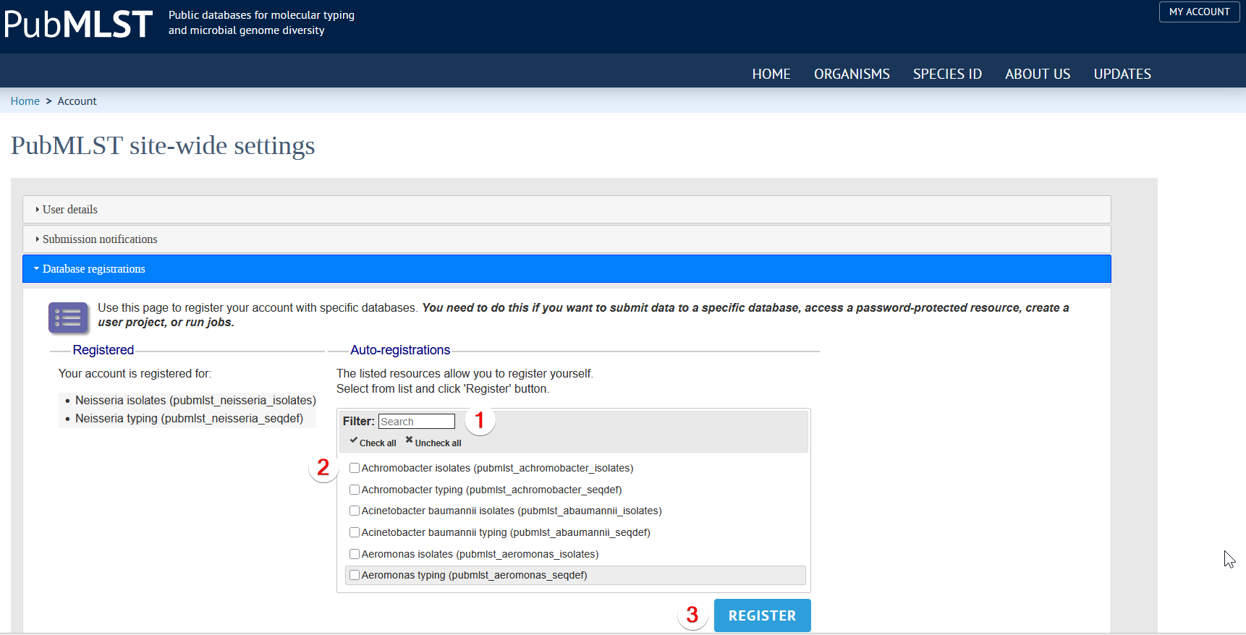

Create a project that contains public datasets of interest
Navigate to the Neisseria isolates database (click on "Organisms", then "Neisseria spp.", and then "Isolate collection").
Click the “+” next to “PROJECTS” and then “Your projects”:
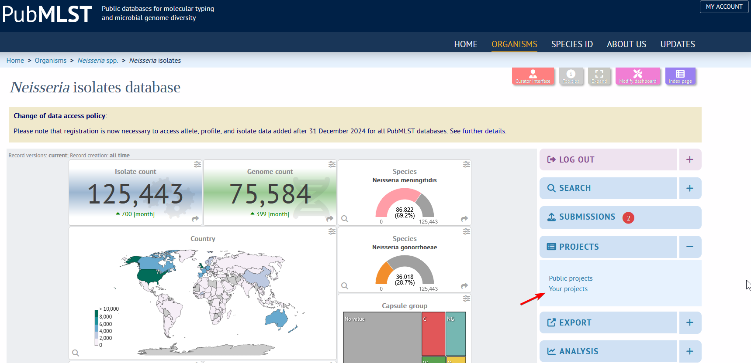

Under "New project", enter the desired name for your dataset and click "Create":
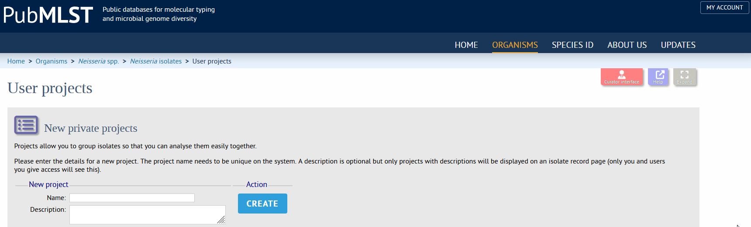

Add isolates records to your project
Navigate to the isolate page by clicking "Neisseria isolates" in the breadcrumb navigation bar:
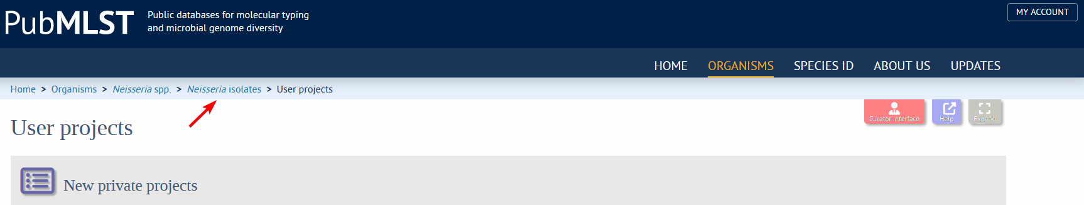

Expand the “Search” menu by clicking the “+” next to “Search”, then click the “Search Database”:
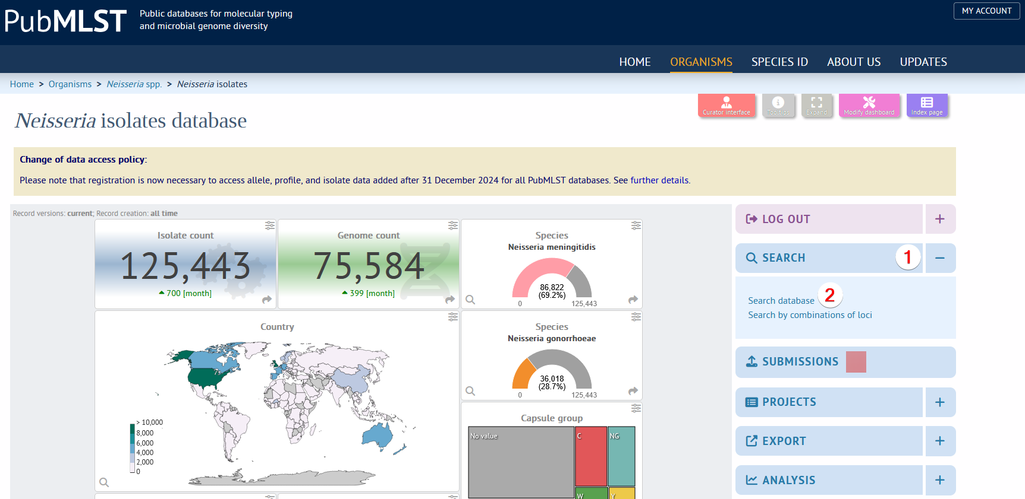

Configure search filters by clicking the "spanner" icon on the upper right panel. Select the "Filters" and close the "spanner's" menu:
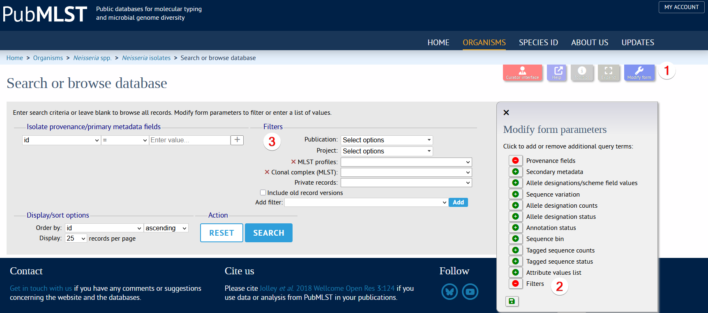

Select "Gonococcal Dataset Antigen Discovery" from the "Project" dropdown menu and then click "Search":
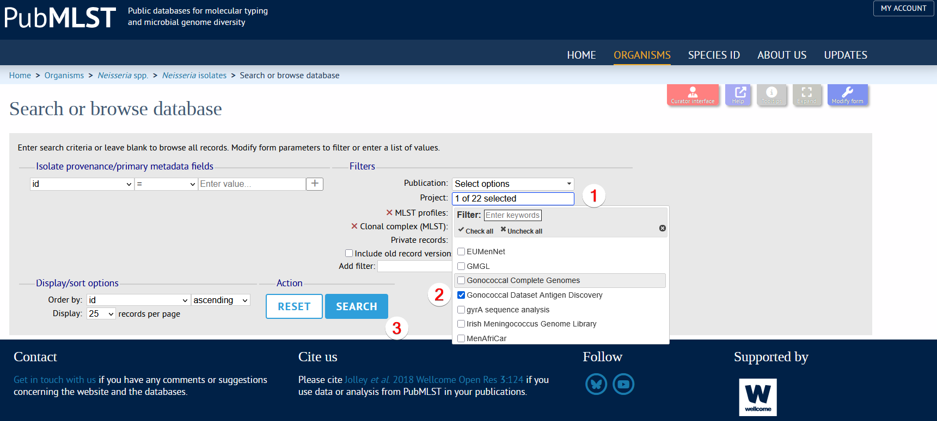

The search returns 15,186 records (as of July 1, 2025):
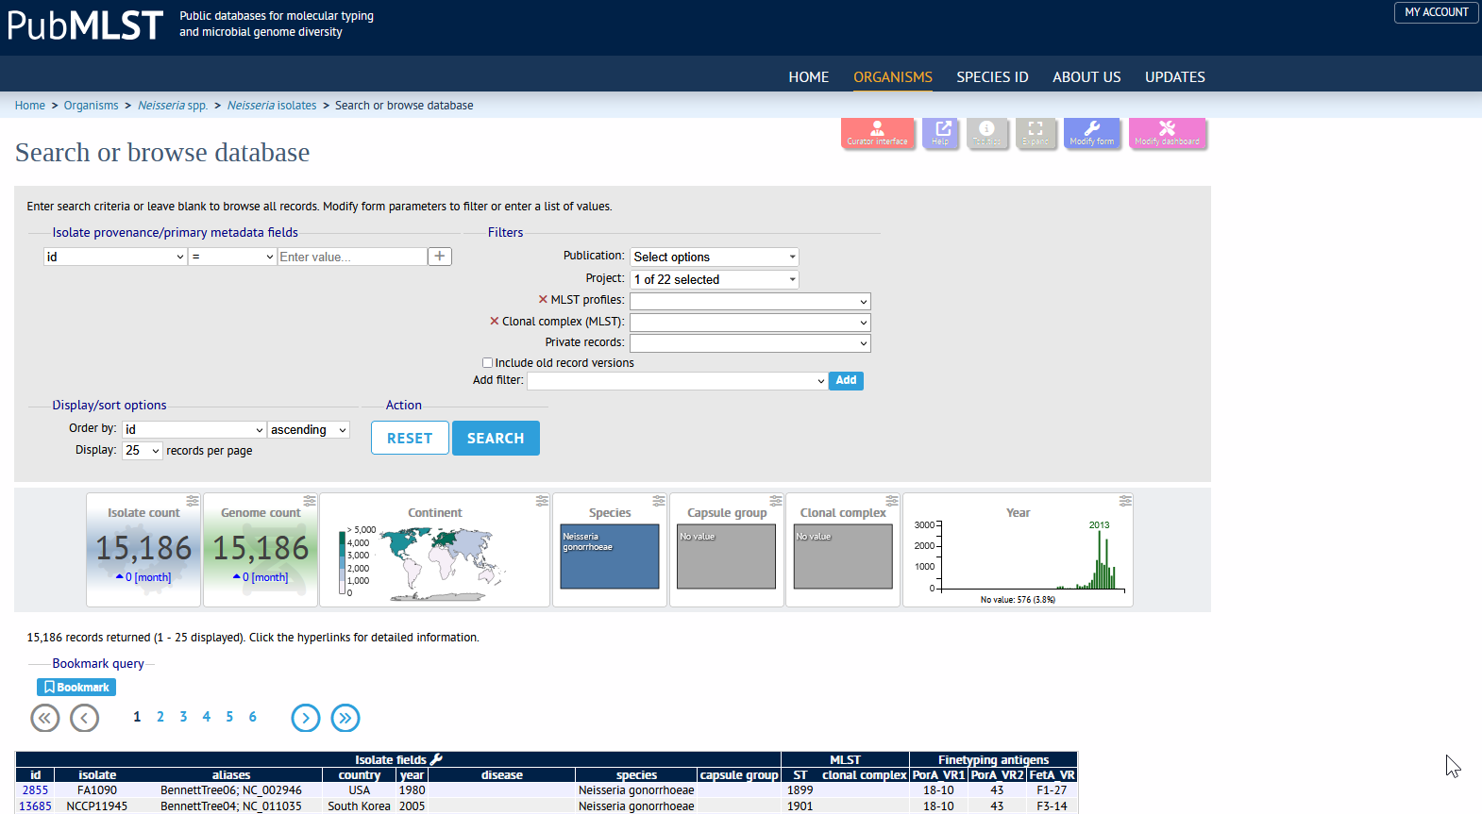

In silico PCR with isolates from the project "Gonococcal Dataset Antigen Discovery"
- Navigate to https://pubmlst.org/organisms/neisseria-spp and click "Isolates":
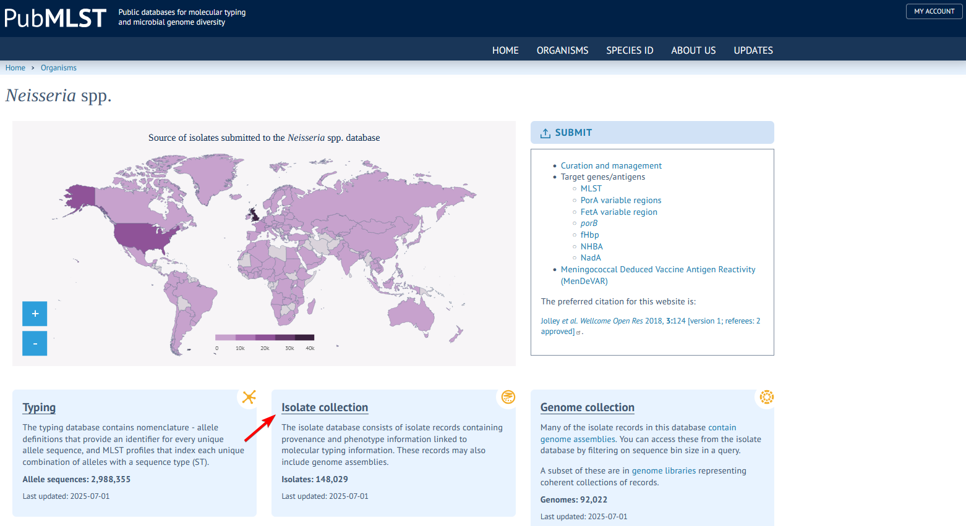

This opens the Neisseria isolates database:
https://pubmlst.org/bigsdb?db=pubmlst_neisseria_isolates
Expand "Projects" by clicking the "+" icon:
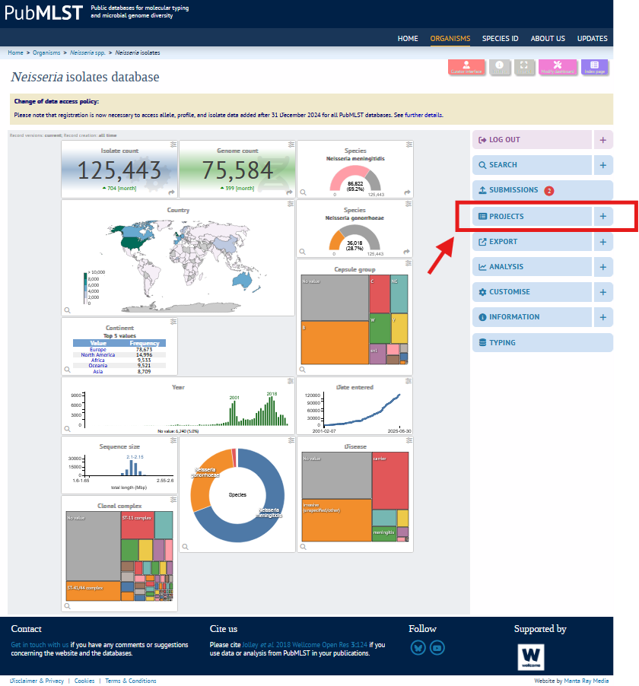
Select "Your projects":
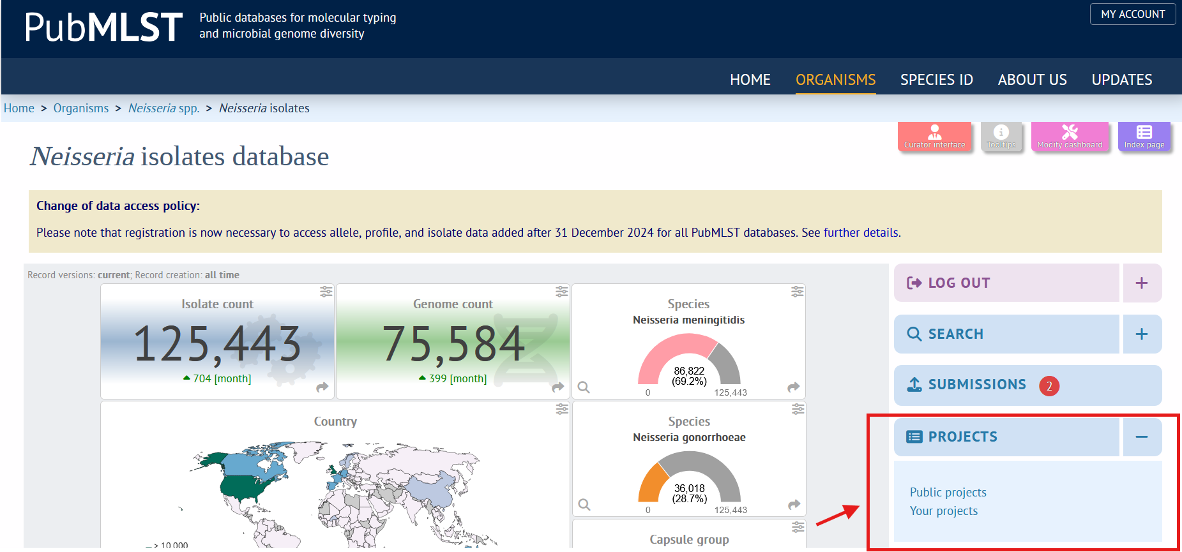

- Select "Gonococcal Dataset Antigen Discovery" under "Your projects" and click "Browse":
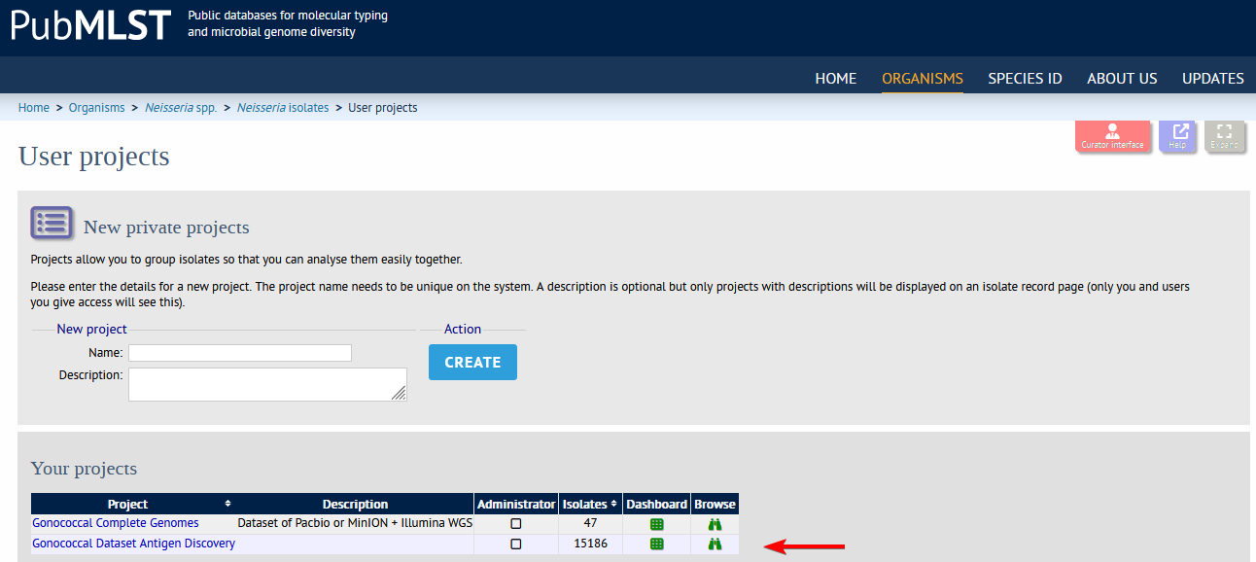

- The "Search or browse database" page displays three sections: Search or Browse, List of Available Isolates, and Analysis Tools: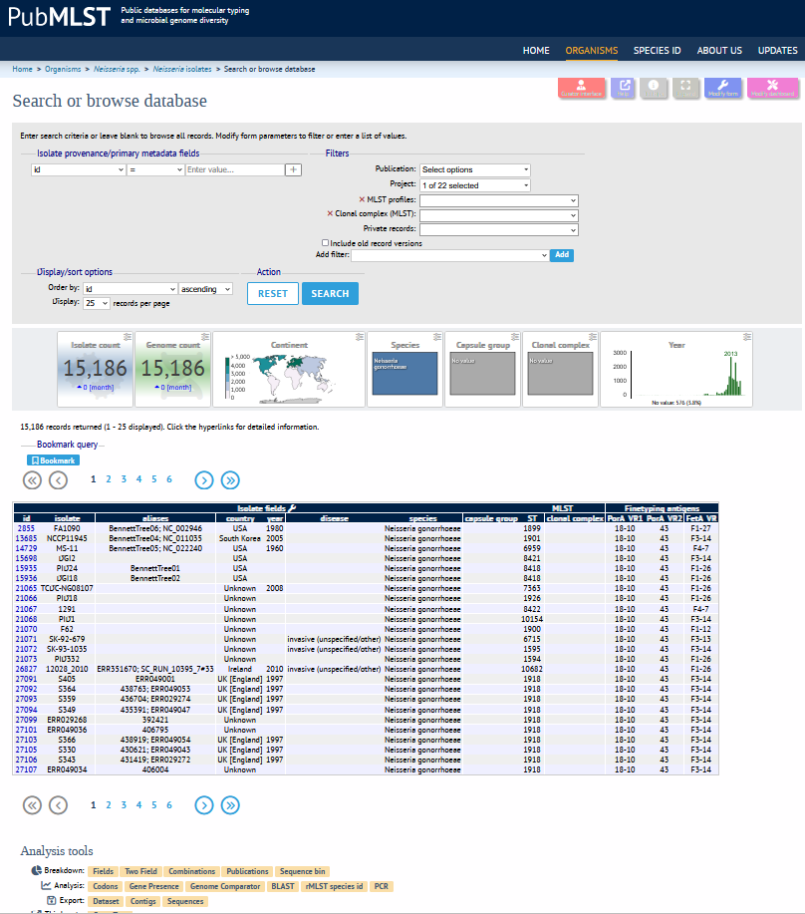

- Navigate to "Analysis tools" at the bottom of the page and click the "PCR" icon:
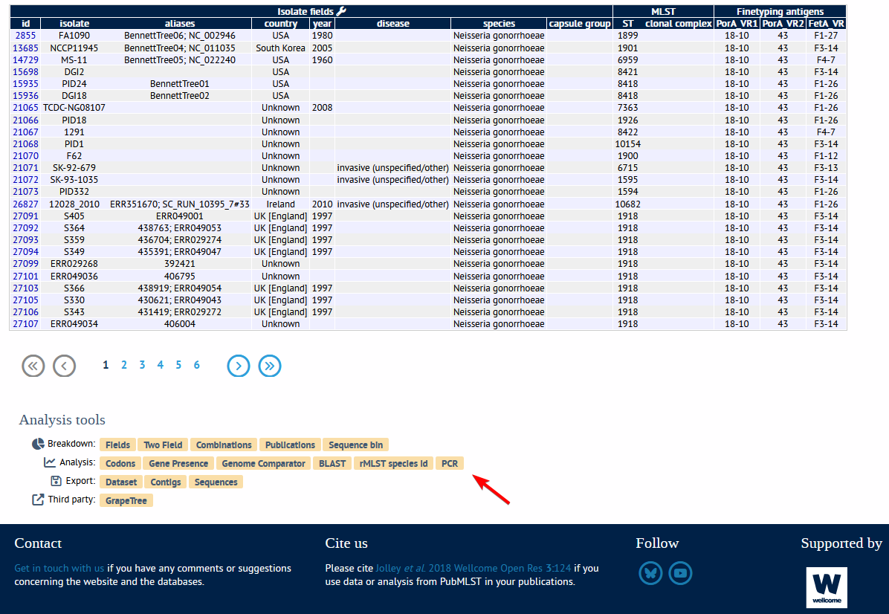
The "In silico PCR" page opens:
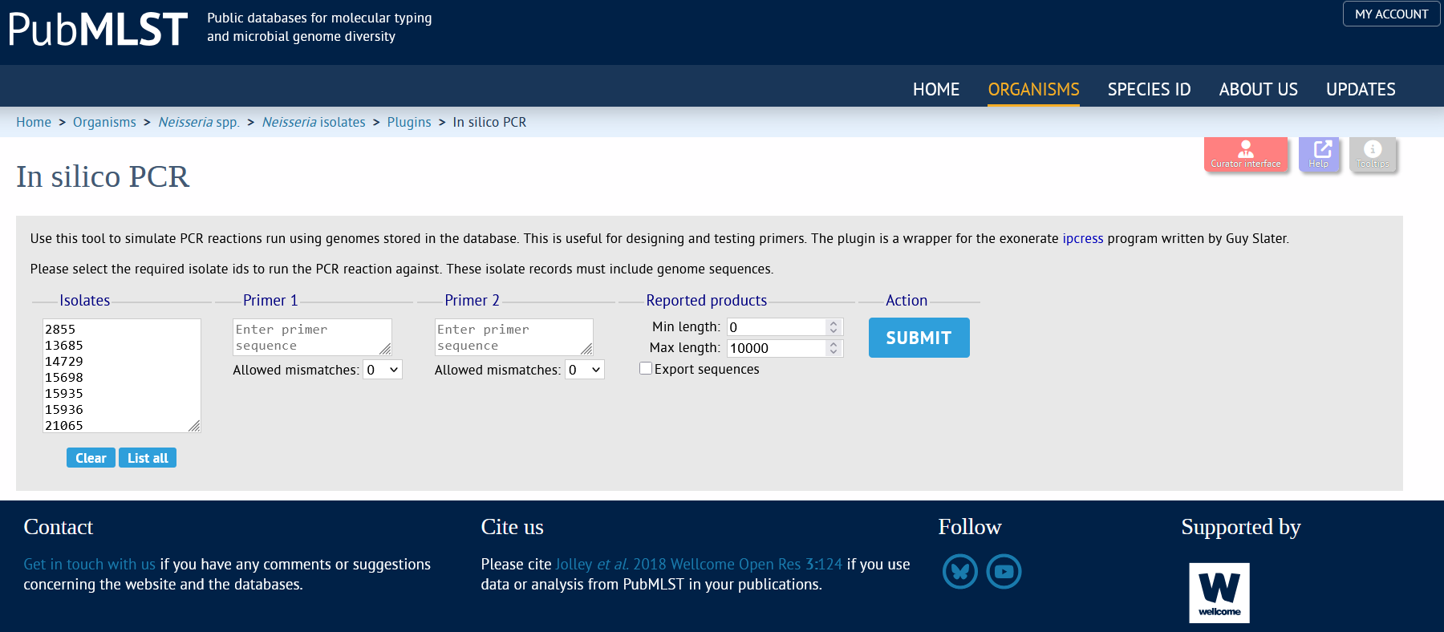

- Copy the isolate list for batch processing
The dataset contains 15,186 N. gonorrhoeae isolates, but PubMLST's in silico PCR tool analyzes a maximum of 10,000 isolates per run. Therefore, divide the analysis into two batches: isolates 1-10,000 and 10,001-15,186.
Click inside the "Isolates" section, press Ctrl+A to select all, then press Ctrl+C to copy the isolate list: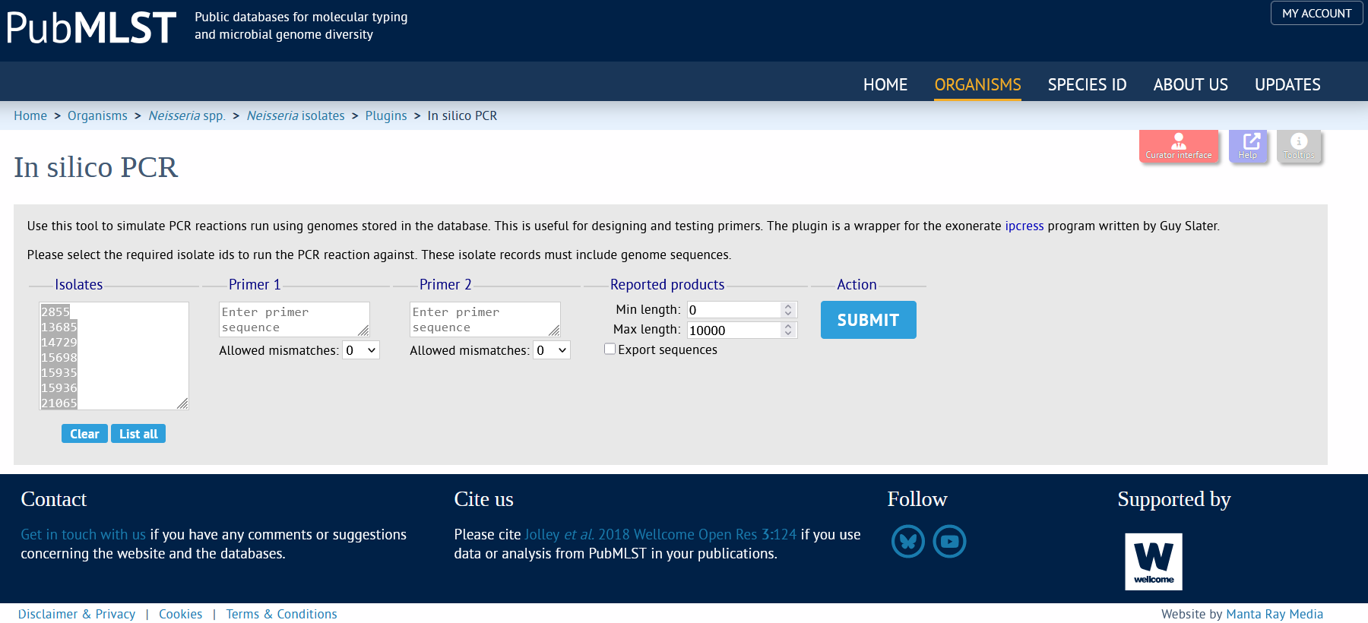
- Prepare batch analysis and configure PCR parameters
Paste the copied isolate list into an Excel column. Select and copy the first 10,000 isolate IDs. Return to the "In silico PCR" page, click "Clear" below the "Isolates" window to remove any pre-loaded IDs from the "Isolates" field, and paste the first batch of data.
Configure PCR settings for the pilE locus:
Enter Primer 1 and 2 sequences (Supplemental Table S1);
Set allowed mismatches (Supplemental Table S1);
Define product length range (min/max) (Supplemental Table S2).
Check "Export sequences" and click "Submit":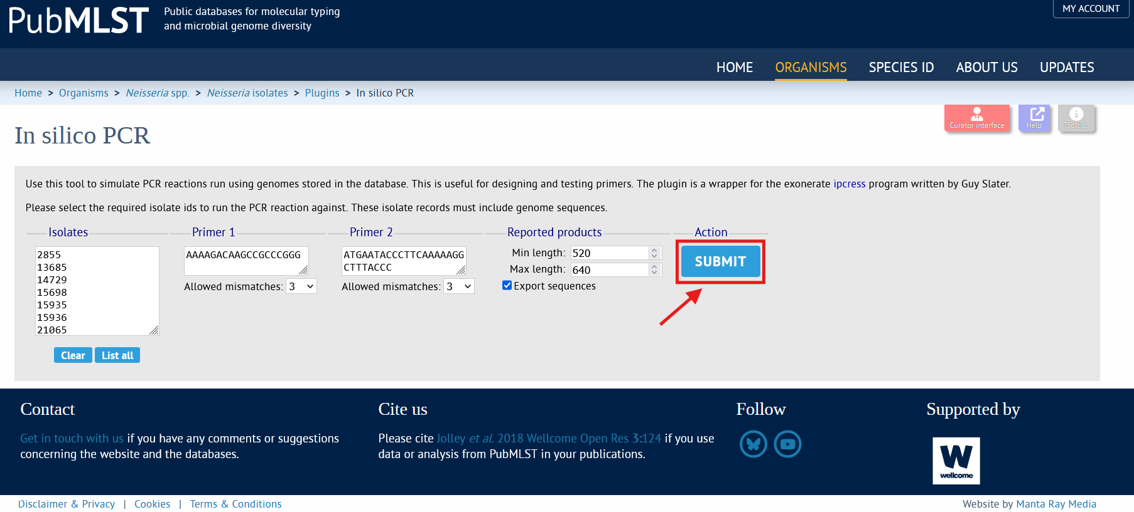

- Wait for the results. Monitor progress on the "Job status viewer" page:
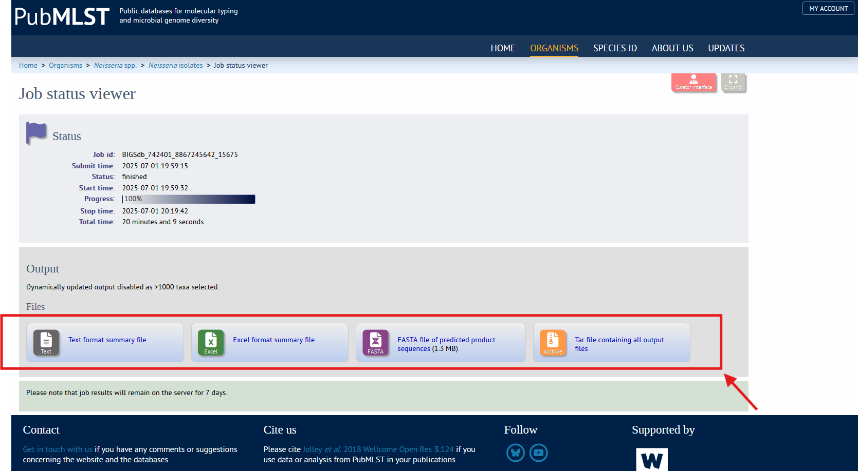
You can download results in the following formats: text file, Excel summary, and a multifasta file of predicted product sequences for downstream analysis. Repeat steps 6-7 for the second batch of data (isolates 10,001-15,186).

Download whole genome sequences of isolates from the assigned project
- Navigate to https://pubmlst.org/organisms/neisseria-spp and click "Isolates".
- Expand "Projects" by clicking the "+" icon.
- Select "Your projects".
- Select "Gonococcal Dataset Antigen Discovery" under "Your projects" and click "Browse".
- Navigate to the "Analysis Tools" at the bottom of the "Search or browse database" page.
- Click the "Contigs" icon in the "Export" subsection.
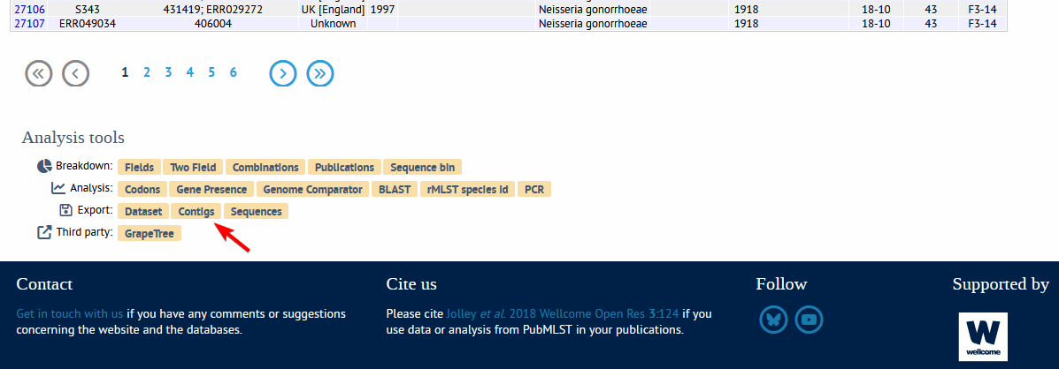

The "Contig analysis and export" page opens.
- Prepare isolate batch for contig export. The "Isolates" window contains a prefilled list of 15,186 N. gonorrhoeae isolate IDs. However, PubMLST's contig export tool processes a maximum of 1,000 isolates per run. Therefore, paste no more than 1000 isolates' IDs per extraction. We selected the first 6 isolate IDs for demonstration purposes.
- Click "Submit".
- The "Sequence bin attributes for selected isolates" page opens.
- Click on an isolate ID number to export contigs (e.g., ID 2855).
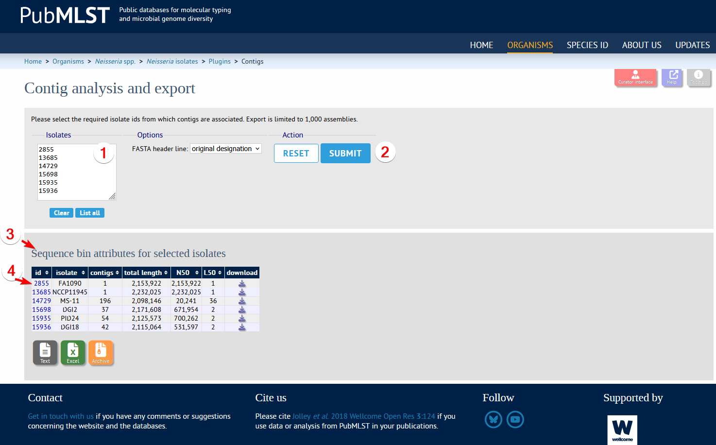

The isolate information page "Full information on isolate FA1090 (id:2855)" opens.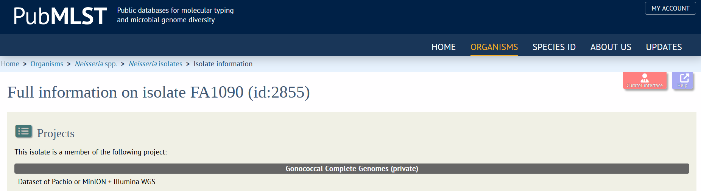
Navigate to the "Sequence bin" section and click "Show sequence bin".
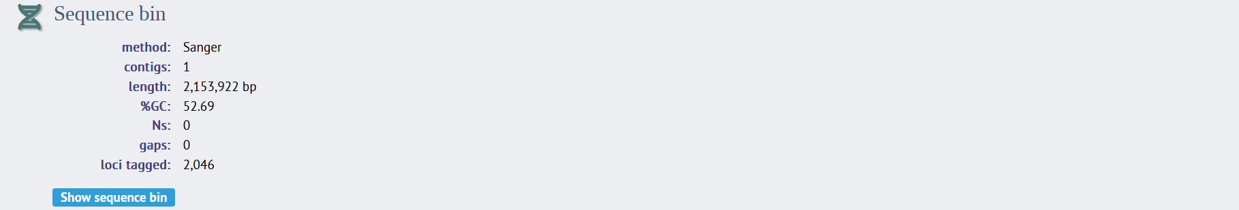
The sequence bin page displays available contig formats for isolate ID 2855.
Click the desired format icon to download: FASTA, EMBL, GBK, or GFF3.
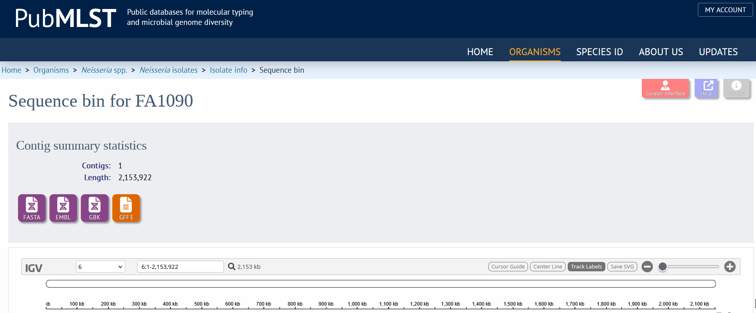

Acknowledgments
This study utilized the PubMLST website (https://pubmlst.org), developed by Keith Jolley and located at the University of Oxford [1]. The Wellcome Trust funded the development of that website. We greatly appreciate Dr. Odile B. Harrison for her skillful, extensive training in using the PubMLST database and genomic analysis.

References
1. Jolley KA, Bray JE, Maiden MCJ. Open-access bacterial population genomics: BIGSdb software, the PubMLST.org website and their applications. Wellcome Open Res. 2018; 3:124.
2. Maiden MCJ, Harrison OB. Population and Functional Genomics of Neisseria Revealed with Gene-by-Gene Approaches. J Clin Microbiol. 2016; 54(8):1949–1955.
3. Jolley KA, Maiden MCJ. BIGSdb: Scalable analysis of bacterial genome variation at the population level. BMC Bioinformatics. 2010; 11:595.
4. Jolley KA. BIGSdb documentation. In silico PCR. [Internet]. [cited 2025 Jul 1]. Available from: https://bigsdb.readthedocs.io/en/latest/data_analysis/in_silico_pcr.html

