Supplemental Data
Supplemental Figure 1
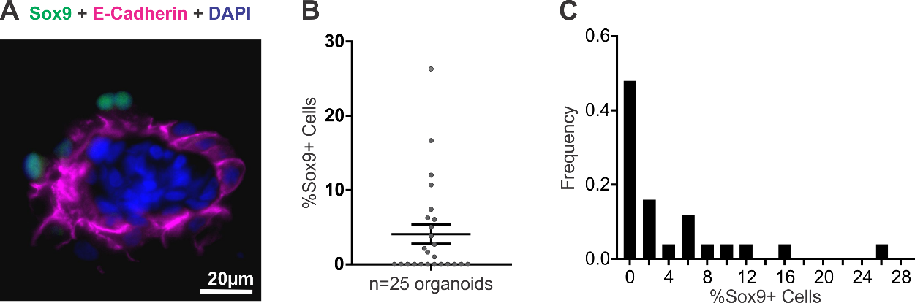
Supplemental Figure 1 Sox9 staining of endometrial organoids. A Immunofluorescent staining for Sox9 (green) and epithelial marker E-cadherin (magenta) on endometrial organoids exposed to stepwise estradiol and testosterone applications to mimic the 14-day follicular phase of a normal menstrual cycle was done. B Quantification of %Sox9+ cells in endometrial organoids (25 organoids obtained from 3 patients) is shown. C A frequency histogram illustrates that the majority of organoids do not contain Sox9 positive cells.

Supplemental Figure 2
Supplemental Figure 2 – FOXA2 staining of endometrial epithelial cells. Immunohistochemistry for FOXA2, glandular epithelial marker was done on endometrial organoids.

