Appendices
A. Further Considerations Regarding Statistical Inference

Performing statistical inference is ubiquitous in costs of illness studies. It is common to report confidence intervals, one sample, paired- and unpaired-samples t-tests, as well as the Wilcoxon’s rank sum test. The statistical theory enabling interpretation of these statistics and procedures assumes the existence of one or more hypothetical populations from which observed data are drawn randomly to form one or several independent random samples. The samples are used to learn certain features of the populations. Statistical imprecision prevents us from learning the features exactly. For example, one may be investigating whether average all-cause costs of care are higher for patients with cirrhosis than in those suffering from COPD, based on two random samples. By chance, the sample means may differ substantially from the population means which are of interest. This motivates the use of statistical inference.

In our statistical analysis, following common research practice, we assume existence of superpopulations from which patients with cirrhosis, COPD and HF insured under MA plans are drawn at random. However, we observe all patients insured by a particular insurance firm. When researchers observe an entire population, its features are known exactly. This makes statistical inference superfluous. A prominent example is the use of administrative claims datasets such as ours, which contain complete data on the population of patients insured by a particular insurer. Still, statistical inference is regularly performed on claims data without discussion of its motivation. (McAdam-Marx et al. (2011), Gordon et al. (2012))

In this setting, researchers may be wary to assert that results are generalizable to all patients, or even to ones insured by other firms. The reason is that patient populations may differ across insurance firms, and insured patients may differ systematically from non-insured ones. If the results are not generalizable to groups of patients other than those observed, inference is redundant. If inference is performed, existence of a superpopulation from which the insured patients are randomly drawn is implicitly assumed. Yet, it may often be unclear what the underlying superpopulation that generates the data may be.

An additional concern that arises when comparing mean costs across different diseases is that one patient may be drawn into multiple samples due to comorbidities. For example, one patient could have both cirrhosis and HF. The often used classical unpaired-samples t-test does not account for the resulting dependence. A simple approach of dropping overlapping units and performing inference using remaining observations yields valid inference on the subpopulation of patients who have no comorbidities. Alternative methods that explicitly account for overlap in order to grant more power may also be used. (Derrick et al. (2017)). However, with a large number of observations, the simple approach may generally suffice. (Derrick, White, Toher (2020)).

References
Derrick, B., Russ, B., Toher, D., & White, P. (2017). Test statistics for the comparison of means for two samples that include both paired and independent observations. Journal of Modern Applied Statistical Methods, 16(1), 9.
Derrick, B., White, P., & Toher, D. (2020). Parametric and non-parametric tests for the comparison of two samples which both include paired and unpaired observations. Journal of Modern Applied Statistical Methods, 18(1), 9.
Gordon, S. C., Pockros, P. J., Terrault, N. A., Hoop, R. S., Buikema, A., Nerenz, D., & Hamzeh, F. M. (2012). Impact of disease severity on healthcare costs in patients with chronic hepatitis C (CHC) virus infection. Hepatology, 56(5), 1651-1660.
McAdam-Marx, C., McGarry, L. J., Hane, C. A., Biskupiak, J., Deniz, B., & Brixner, D. I. (2011). All-cause and incremental per patient per year cost associated with chronic hepatitis C virus and associated liver complications in the United States: a managed care perspective. Journal of Managed Care Pharmacy, 17(7), 531-546.

B. Denied Claims and Service Lines
Some or all service lines in a given claim may be denied by the insurer. Hence, a claim may be partially or fully denied. We will henceforth use the terms denied service lines and denied claims interchangeably to refer to the denied portion of a claim. To the extent of our knowledge, denied service lines have been overlooked in existing cost of illness analyses based on administrative claims data. Denied claims are unavailable in commonly used claims datasets. Even when they are available, repeated refilings of the same claim and lack of information on reasons behind denial make it difficult to include relevant denied service lines into the analysis. These factors may be contributing to perpetuation of established practice. A crucial implicit assumption behind omission of denied claims is that none of them pertain to provided and medically appropriate services and items.
Omission of denied service lines from cost analysis may not be innocuous. Initial approval or denial is usually done through an automated billing system. Claims may be denied for a multitude of reasons beyond medical necessity, such as untimely filing, failure to precertify or preauthorize, coding errors, plan coverage, typographical errors in patient’s name or plan number, or even potential errors in the billing system. Providers are notified of adjustments or denials via electronic remittance advice detailing the reasons, and they can choose whether to pursue the matter further.

If providers disagree with the insurer’s adjudication, they may refile claims or initiate formal appeals. Due to high bureaucratic costs, they may instead choose to write off lost revenue or, in certain cases, bill the patients directly when contractually and legally allowed. (Dunn et al. (2023)) In either case, the corresponding service lines will be marked as denied in the data, despite possibly pertaining to a potentially relevant service or item that contributes to real cost of illness. This component of cost is then borne by the provider or patient. Depending on the perspective, it may or may not be a relevant factor in the analysis. Since we take the healthcare sector perspective, any cost borne by providers and patients is relevant. Hence, omission of denied claims may downward bias cost estimates.
In our population, 32.4% of all available service lines were denied. Unfortunately, incorporating relevant denied claims into our analysis would be a complex task, which we could perform only with due recognition of uncertainty. Due to dataset limitations, we cannot claim with certainty how many denied claims pertain to multiple refilings for the same clinical services, nor which denied claims were eventually approved for payment. Additionally, we cannot be certain which denied claims correspond to actually provided and medically necessary services and items. We see measurement of wrongly omitted denied service lines and development of guidelines for their adequate inclusion as fruitful directions for future research on medical costs.

References
Dunn, A., Gottlieb, J. D., Shapiro, A., Sonnenstuhl, D. J., & Tebaldi, P. (2023). A Denial a Day Keeps the Doctor Away, The Quarterly Journal of Economics;, https://doi.org/10.1093/qje/qjad035

C. Supplemental Tables and Figures
Supplemental Table 1: Detailed summary of preventative services toward cost
Costs | Total Cirrhosis | Compensated Months | Decompensated Months
Total Costs; mean (SD), % of total cost | 3031.96 (8825.46), 100.00% | 1749.64 (5103.86), 100.00% | 3969.28 (10663.03), 100.00%
Medical Costs; mean (SD), % of total cost | 2288.88 (8237.97), 75.49% | 1046.61 (3879.25), 59.82% | 3196.92 (10223.35), 80.54%
Inpatient Medical Costs; mean (SD), % of total cost | 1250.71 (7580.08), 41.25% | 355.75 (3079.93), 20.33% | 1904.88 (9566.04), 47.99%
Emergency Medical Costs; mean (SD), % of total cost | 87.55 (404.14), 2.89% | 39.82 (236.79), 2.28% | 122.45 (488.72), 3.08%
Other Medical Costs; mean (SD), % of total cost | 950.62 (2821.84), 31.35% | 651.03 (2174.72), 37.21% | 1169.60 (3195.73), 29.47%
Pharmacy Costs; mean (SD), % of total cost | 743.08 (3109.43), 24.51% | 703.03 (3260.67), 40.18% | 772.35 (2993.71), 19.46%
Diuretics | 2.24 (15.19), 0.07% | 1.08 (9.42), 0.06% | 3.08 (18.23), 0.08%
Antibiotics | 0.59 (10.78), 0.02% | 0.47 (8.71), 0.03% | 0.68 (12.07), 0.02%
Rifaximin | 65.03 (496.52), 2.14% | 14.16 (226.35), 0.81% | 102.12 (621.02), 2.57%
HE Dissacharides | 2.29 (40.89), 0.08% | 0.73 (13.38), 0.04% | 3.43 (52.51), 0.09%
Cardiovascular Drugs | 4.72 (193.81), 0.16% | 5.79 (240.99), 0.33% | 3.93 (150.35), 0.10%
Midodrine | 0.47 (9.42), 0.02% | 0.12 (4.64), 0.01% | 0.73 (11.72), 0.02%
Beta Blockers | 7.06 (36.78), 0.23% | 6.19 (36.31), 0.35% | 7.69 (37.10), 0.19%
Biliary Antiviral | 5.26 (234.27), 0.17% | 9.79 (320.61), 0.56% | 1.96 (141.16), 0.05%
Thiamine | 0.00 (0.01), 0.00% | 0.00 (0.00), 0.00% | 0.00 (0.01), 0.00%
Autoimmune Steroids | 0.40 (6.45), 0.01% | 0.40 (5.70), 0.02% | 0.40 (6.95), 0.01%
Autoimmune suppression | 0.44 (10.39), 0.01% | 0.61 (12.53), 0.03% | 0.32 (8.48), 0.01%
HCV Interferons | 2.35 (130.29), 0.08% | 3.88 (163.14), 0.22% | 1.24 (99.73), 0.03%
HCV DAAs | 133.25 (2342.02), 4.39% | 172.81 (2657.58), 9.88% | 104.41 (2081.54), 2.63%
Anti Coagulation Drugs | 0.54 (6.38), 0.02% | 0.39 (5.81), 0.02% | 0.65 (6.76), 0.02%
Statins | 4.78 (32.76), 0.16% | 4.94 (34.63), 0.28% | 4.67 (31.33), 0.12%
EGD; mean (SD), % of total cost | 3.75 (74.33), 0.12% | $0.06 (10.86), 0.00% | $6.40 (97.26), 0.15%

Supplemental Table 1 Legend: This table (presently not included in the manuscript) shows the costs of individual preventative services typically provided to patients with compensated cirrhosis. Percentages demonstrate their relative magnitude.
Abbrev: DAA: Direct-acting antiviral; EGD: xxx, HCV: Hepatitis C virus; HE: Hepatic encephalopathy; SD: Standard deviation

Supplemental Table 2: Total cost per patient-month for patients younger than 65 years of age with cirrhosis

Costs | Total Cirrhosis (n = 22327) | Compensated (n = 7147) | Decompensated (n = 15180)
Total Costs; mean (SD), % of total cost | 3738.75 (10448.81), 100.00% | 2351.37 (6330.62), 100.00% | 4708.71 (12458.02), 100.00%
Medical Costs; mean (SD), % of total cost | 2513.88 (9425.79), 67.24% | 1145.63 (4112.38), 48.72% | 3470.48 (11701.00), 73.70%
Inpatient Medical Costs; mean (SD), % of total cost | 1460.67 (8831.34), 39.07% | 424.58 (3253.98), 18.06% | 2185.04 (11128.45), 46.40%
Emergency Medical Costs; mean (SD), % of total cost | 125.69 (503.17), 3.36% | 61.35 (296.56), 2.61% | 170.67 (603.14), 3.62%
Other Medical Costs; mean (SD), % of total cost | 927.52 (2851.61), 24.81% | 659.70 (2325.52), 28.06% | 1114.77 (3154.47), 23.67%
Pharmacy Costs; mean (SD), % of total cost | 1224.86 (4500.07), 32.76% | 1205.74 (4761.22), 51.28% | 1238.23 (4308.06), 26.30%

Supplemental Table 2 (continued): Total cost per patient-month for patients younger than 65 years of age with HF and COPD

Costs | HF (n = 37692) | COPD (n = 50763)
Total Costs; mean (SD), % of total cost | 3572.22 (10732.74), 100.00% | 2518.77 (7376.51), 100.00%
Medical Costs; mean (SD), % of total cost | 2617.70 (10323.07), 73.28% | 1661.85 (6840.17), 65.98%
Inpatient Medical Costs; mean (SD), % of total cost | 1440.40 (9784.01), 40.32% | 819.79 (6303.98), 32.55%
Emergency Medical Costs; mean (SD), % of total cost | 124.16 (481.01), 3.48% | 89.84 (393.15), 3.57%
Other Medical Costs; mean (SD), % of total cost | 1053.13 (2867.33), 29.48% | 752.22 (2281.78), 29.86%
Pharmacy Costs; mean (SD), % of total cost | 954.53 (2808.93), 26.72% | 856.92 (2625.83), 34.02%

Supplemental Table 2 Legend: Mean total cost per patient-month for patients under the age of 65 with cirrhosis, HF, and COPD. Cirrhosis is stratified by compensated and decompensated cirrhosis and components of costs are listed.

Abbrev: COPD: Chronic obstructive pulmonary disease; HF: Heart failure; SD: Standard deviation

Supplemental Table 3: Total cost per patient-month for patients 65 years of age and older with cirrhosis
Costs | Total Cirrhosis (n = 70981) | Compensated (n = 23619) | Decompensated (n = 47362)
Total Costs; mean (SD), % of total cost | 2841.05 (8322.62), 100.00% | 1592.35 (4718.43), 100.00% | 3764.77 (10100.95), 100.00%
Medical Costs; mean (SD), % of total cost | 2228.11 (7885.39), 78.43% | 1020.72 (3815.54), 64.10% | 3121.27 (9773.99), 82.91%
Inpatient Medical Costs; mean (SD), % of total cost | 1194.00 (7203.87), 42.03% | 337.76 (3032.53), 21.21% | 1827.39 (9085.10), 48.54%
Emergency Medical Costs; mean (SD), % of total cost | 77.25 (372.24), 2.72% | 34.19 (218.14), 2.15% | 109.11 (451.09), 2.90%
Other Medical Costs; mean (SD), % of total cost | 956.86 (2813.72), 33.68% | 648.77 (2133.54), 40.74% | 1184.77 (3206.88), 31.47%
Pharmacy Costs; mean (SD), % of total cost | 612.95 (2594.34), 21.57% | 571.63 (2720.73), 35.90% | 643.51 (2496.28), 17.09%

Supplemental Table 3 (continued): Total cost per patient-month for patients 65 years of age and older with HF and COPD

Costs | HF (n = 317828) | COPD (n = 268186)
Total Costs; mean (SD), % of total cost | 2382.08 (7329.41), 100.00% | 1867.83 (5946.62), 100.00%
Medical Costs; mean (SD), % of total cost | 1964.21 (7147.86), 82.46% | 1471.87 (5741.03), 78.80%
Inpatient Medical Costs; mean (SD), % of total cost | 1022.37 (6522.63), 42.92% | 697.35 (5160.53), 37.33%
Emergency Medical Costs; mean (SD), % of total cost | 69.50 (337.04), 2.92% | 53.56 (290.08), 2.87%
Other Medical Costs; mean (SD), % of total cost | 872.33 (2591.63), 36.62% | 720.96 (2175.23), 38.60%
Pharmacy Costs; mean (SD), % of total cost | 417.88 (1497.97), 17.54% | 395.96 (1413.05), 21.20%

Supplemental Table 3 Legend: Mean total cost per patient-month for patients aged 65 years and older with cirrhosis, HF, and COPD. Cirrhosis is stratified by compensated and decompensated cirrhosis and components of costs are listed.

Abbrev: COPD: Chronic obstructive pulmonary disease; HF: Heart failure; SD: Standard deviation

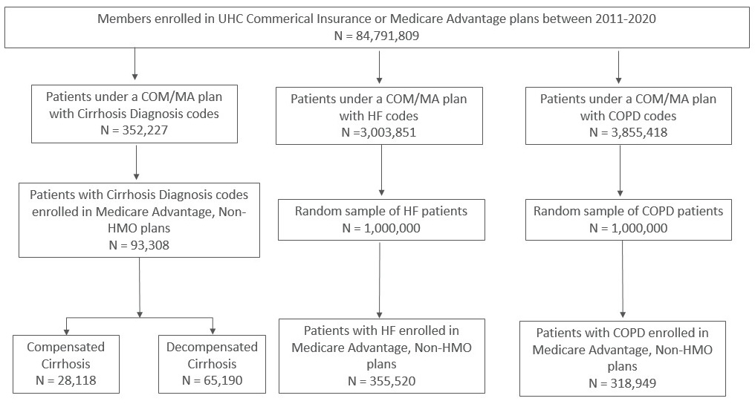
Supplemental Figure 1 Legend: Diagram demonstrating the method of cohort formation for cirrhosis, HF, and COPD.

Abbrev: COM: Commercial; COPD: Chronic obstructive pulmonary disease; HF: Heart failure; HMO: Health maintenance organization; MA: Medicare Advantage

Supplemental Figure 2: Hospitalization rate by year for patients with cirrhosis, HF, and COPD

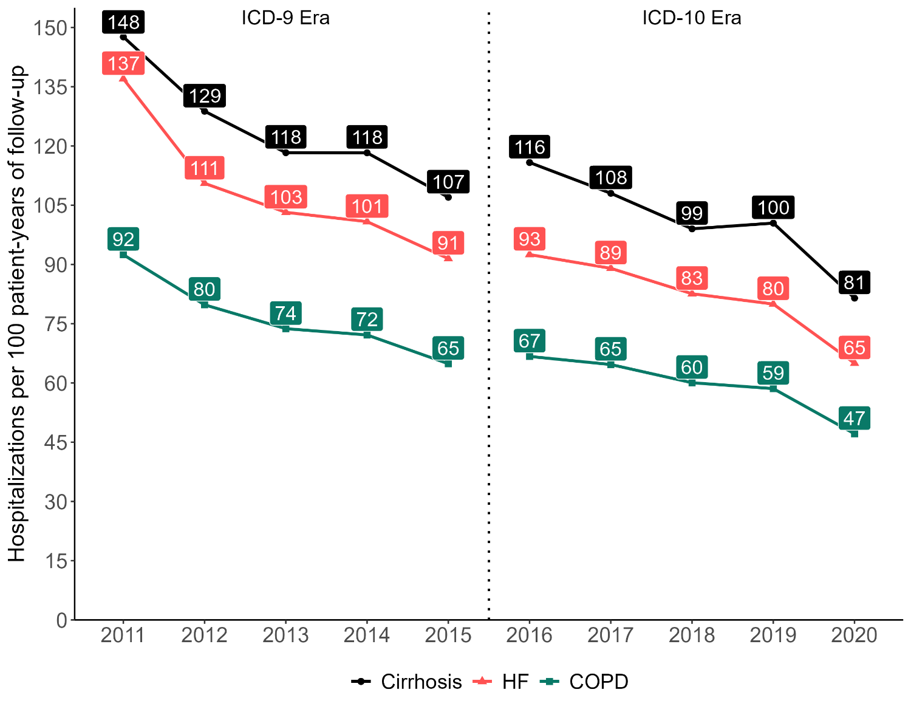
Supplemental Figure 2 Legend: Hospitalizations per 100 patients per year for patients with cirrhosis, HF, and COPD by calendar year. Continuous reduction of hospitalization over study period.
Abbrev: COPD: Chronic obstructive pulmonary disease; ICD: International Classification of Diseases; HF: Heart failure

Supplemental Figure 3: Number of enrolled patients with cirrhosis, HF, and COPD by year

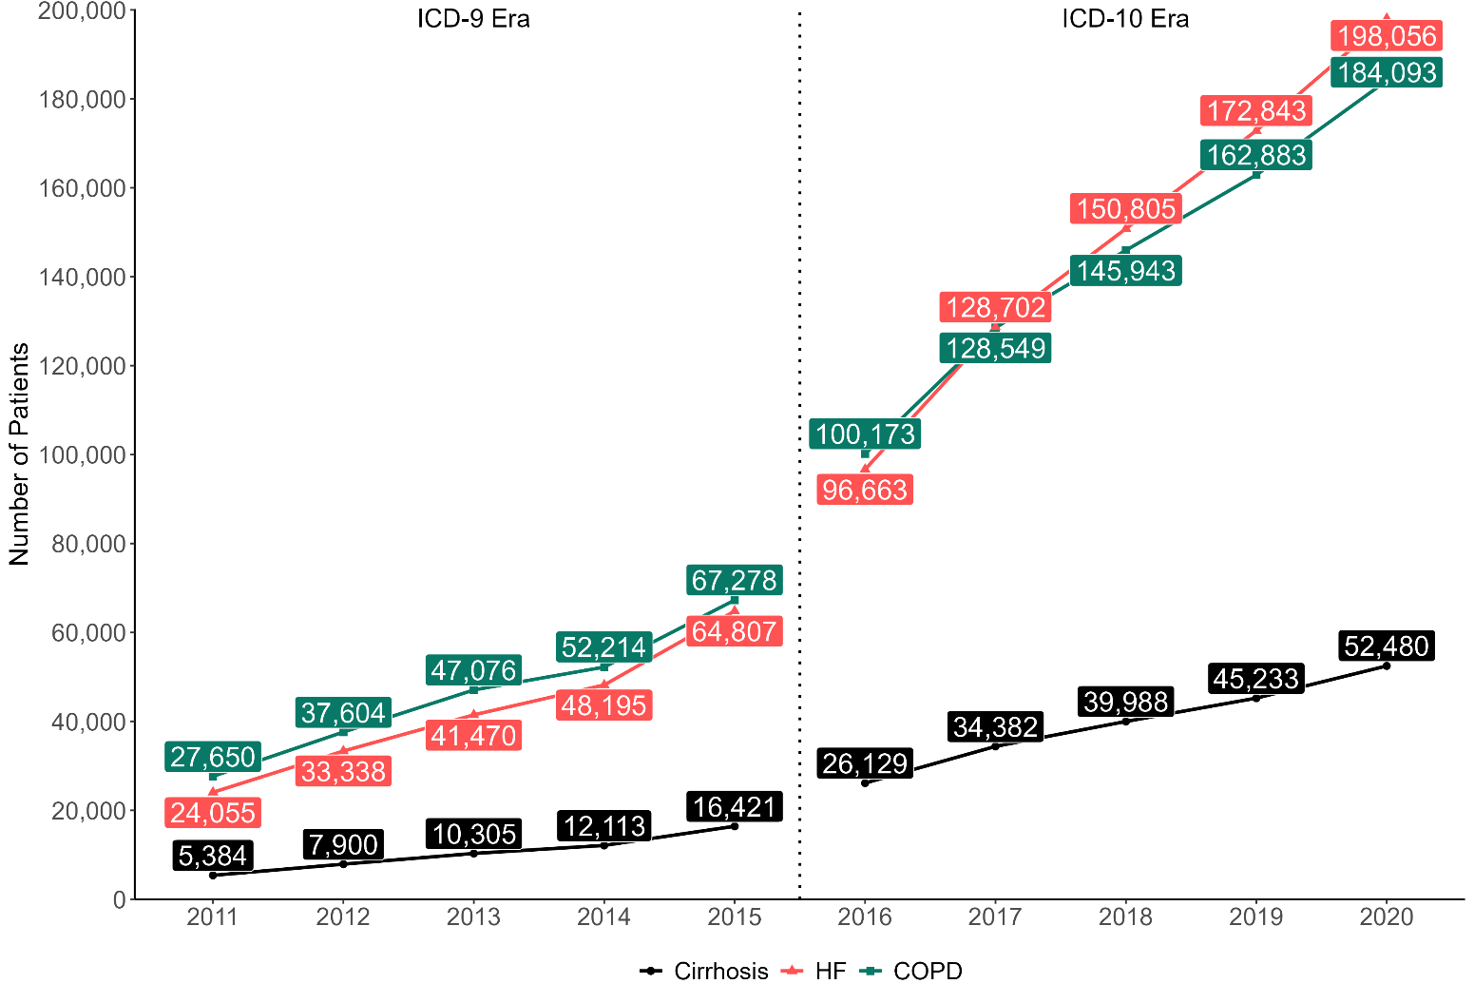
Supplemental Figure 3 Legend: Number of patients with cirrhosis, HF, and COPD by calendar year. Continuous increase over study period.
Abbrev: COPD: Chronic obstructive pulmonary disease; ICD: International Classification of Diseases; HF: Heart failure

Supplemental Figure 4: Mean follow-up for patients with cirrhosis, HF, and COPD

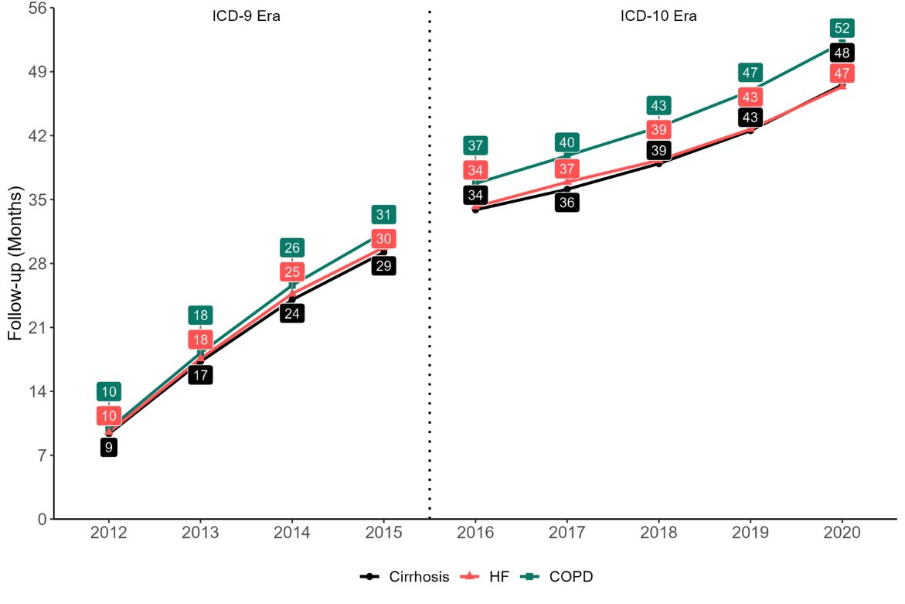
Supplemental Figure 4 Legend: Mean cohort follow up in months for patients with cirrhosis, HF, and COPD by calendar year, diagnosed in any prior year. Continuous increase over study period.
Abbrev: COPD: Chronic obstructive pulmonary disease; ICD: International Classification of Diseases; HF: Heart failure

Supplemental Figure 5: Mean total cost by year for patients with cirrhosis, HF, and COPD

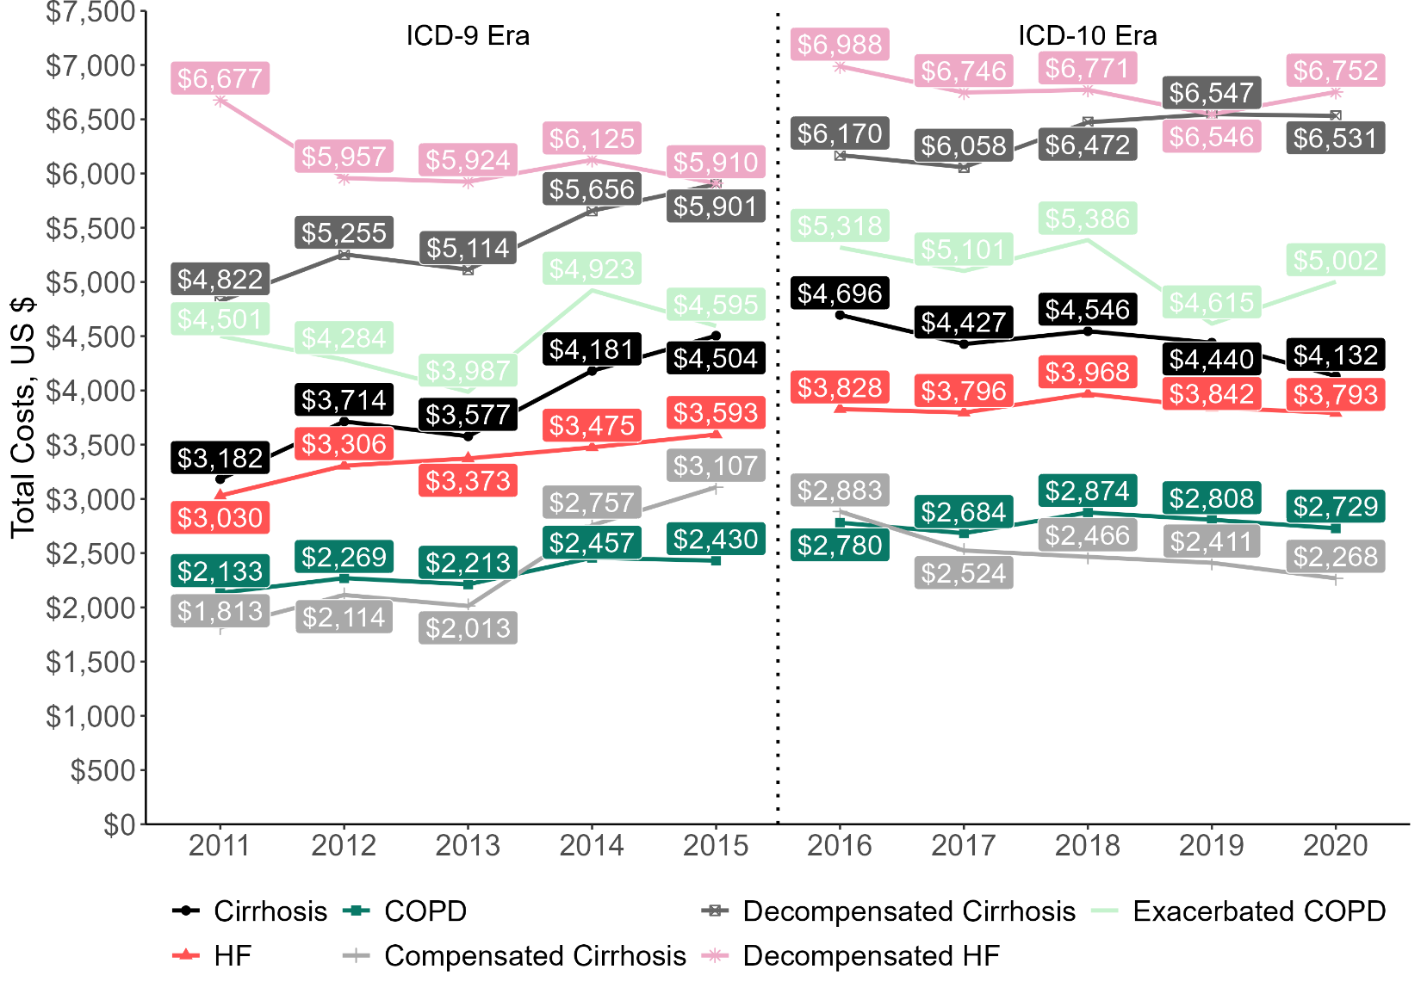
Supplemental Figure 5 Legend: Mean total cost per patient-month by year for patients with cirrhosis, for individuals diagnosed in the same year. In addition to showing costs for compensated and decompensated cirrhosis, it also shows costs for compensated HF, decompensated HF, non-exacerbated COPD, and exacerbated COPD patient-months.
Abbrev: COPD: Chronic obstructive pulmonary disease; HF: Heart failure; US: United States; $: United States Dollars

